Delaware PBS Key Feature Evaluation
Developed team includes:
Eileen Baker, George Bear, Debby Boyer, and Sarah Hearn (UD/CDS) with support from Linda Smith (DDOE).
History:
Since 2008, the DE-PBS Project has worked extensively with local school districts and knowledgeable researchers to develop a more comprehensive philosophy of Positive Behavior Support in Delaware. Those efforts resulted in the development of the 10 DE-PBS Key Features in 2009. According to these features, DE-PBS schools aim to “create safe and caring learning environments that promote the social-emotional and academic development of all children.” Because this definition of DE-PBS is so comprehensive, existing evaluation tools like the SET are no longer sufficient for evaluating DE-PBS schools. For over two years, a development team has been working on what is now our Delaware PBS Key Feature Evaluation. After piloting in a few school sites, this tool will be finalized and rolled out in Spring 2012. The new evaluation will be conducted with all active DE-PBS schools over the next few years. We look forward to providing schools with meaningful information about their DE-PBS practices.
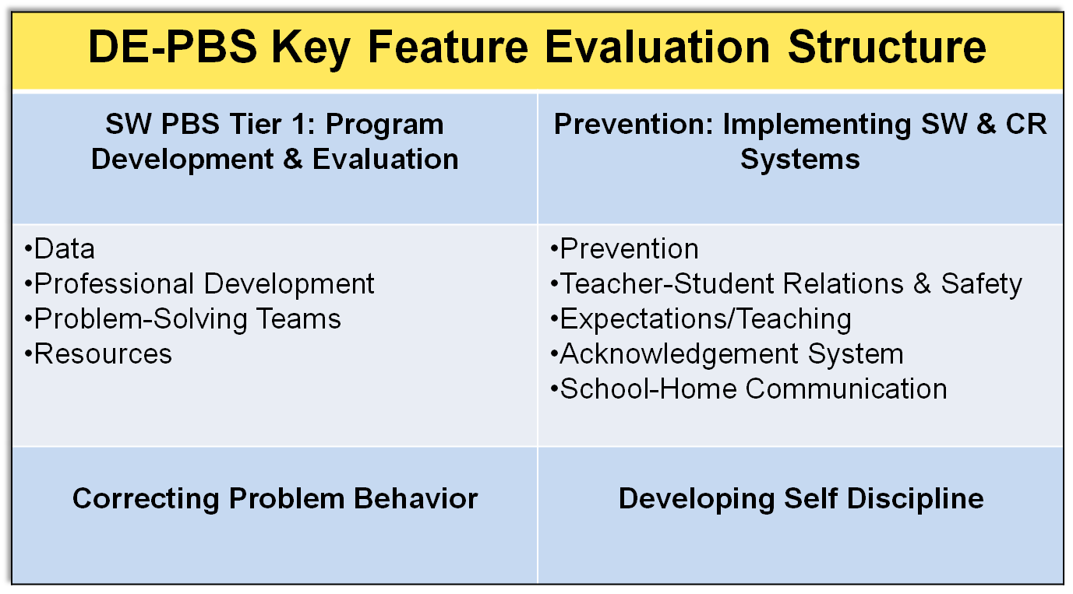
DE-PBS Key Feature Evaluation Process:  - On-site Evaluation (approx. 3-4 hours)  - Sources of Information:  - Interviews with teachers/staff, administrator, DE-PBS team leader, student  - Review of documents  - Schoolwide observations  - Existing data: School Climate Surveys, DASNPBS | DE-PBS Key Feature Evaluation Feedback:  - School receives score on essential items in 4 categories  - Graph (future will include multiple years)  - Narrative summary of evaluation information gathered  - Highlight strengths  - Note areas for improvement  - Include recommendations for program improvements, professional development opportunities, and resources  - Provided to school and district coach
For more information, contact Sarah Hearn with the DE-PBS Project (skhearn@udel.edu).

