Cape Henlopen School District
Richard A. Shields Elementary
Positive Behavior Support Meets Growth Mindset

Richard A. Shields Elementary School Principal: Jenny Nauman
910 Shields Ave. Assistant Principal: David McDowell
Lewes, DE 19958 PBS Co-coaches: Heidi C. Quillen, Kim Corbidge
(302) 645-7748 Heidi.Quillen@cape.k12.de.us

PBS/Growth Mindset Matrix:

SCHOOL RULES | ACADEMIC | BEHAVIOR
Be Ready to Learn | Open to new strategies  Experiment with new ideas  Problem solve | Follow directions  Have supplies ready  Ready to attend
Be Ready to Try Again | Rewrite/redo/fix it  Learn from mistakes  Choose another strategy | Follow adult prompts  Make a better choice  Use calm positive self talk
Be Ready to Accept Help | Seek out critiques of work  Learn from corrections  Use support to improve | Reflection/goal setting  Use behavior strategies  Accept consequence
Be Ready to Care | Do your best work  Have pride in your work  Work toward improvement | Show kindness to others  Attend to own emotions  Take care of environment
Be Ready to Lead | Take academic risks  Share ideas with others  Find a new way | Follow rules  Solve conflicts  Build a caring community

PBS/Growth Mindset School Rules Graphic:
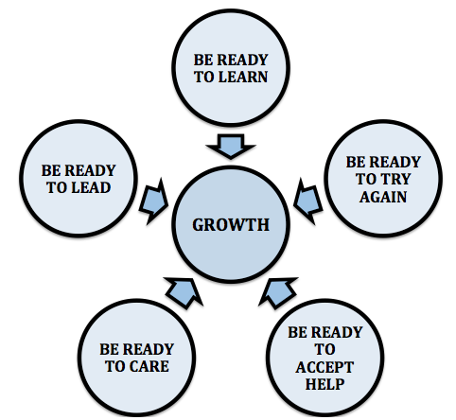

PBS Growth Mindset School  Rules   ➔ | Teaching Growth Mindset  School Rules | Teaching Behavior  Expectations | Developing  Self  Discipline | Student  Voice | Parent  Involvement | Professional  Development and  Support | Preventative Classroom  Management | Short term reward | Long term reward | Discipline | Data Collection
Be Ready to Learn  Be Ready to Try Again  Be Ready to Accept Help  Be Ready to Care  Be Ready to Lead   ➔ | Teach Growth Mindset language  Classroom lessons on brain science  Explore Growth Mindset literature and media  School-wide units on PBS and Growth Mindset throughout the year:  -Mistakes that have resulted in successes  -Historical or contemp-orary figures who have persevered through hardship  -Explore leadership  qualities  -Study the impact of teamwork in success  -Community service projects | Teach basic behavior expectations at the beginning of the year and review as necessary:  -Hall  -Bathroom  -Cafeteria  -Playground  -Bus | Use Growth Mindset language to teach perseverance and self correction  Teach Second Step lessons in each classroom  Incorporate Second Step strategies into a school-wide focus throughout the year:  -Peacemaker  Recognition Program  -Use of visuals  -Apply Second Step strategies in problem solving  -Incorporate in morning announce-ments  Restorative Practice:  -Reflections  -Circles | Led by Cape Accelerated Program students  Student surveys  Student PBS  Climate Survey Data | Teach Growth Mindset language to parents  Weekly contact with parents regarding classroom behavior for each student  Parent Rep on the PBS Team  Parent Newsletter “Growing with PBS”  Parent resources on the school website  with a link to a PBS Weebly website  PTO and Open House  Present-ations on PBS and Growth MIndset | PBS rep also is the grade level Lead Teacher on behavior interventions  Professional literature on Growth Mindset available to all staff  Growth Mindset Book Clubs  Behavior interventions discussed during Learning Labs  PBS State-wide training  Resource sharing through list serve  Intervention resource manual available in the staff lounge  Admin support for PBS meeting time | Use Growth Mindset and school rules as language for classroom prompts and specific praise  Classroom management works toward increased adult support  Consequences are natural and/or logical  Behavior interventions made available to all staff with support  Use Second Step language for calming strategies and problem solving  Use Restorative  Practices for student conferences and class circles | Specific praise in Growth Mindset language  Peacemaker Recognition Award using school rules, growth mindset, and Second Step  language  Bus Recognition Award  Individual Classroom rewards  New Dolphin Dollar has school rule graphic | Monthly celebrations at class, grade, or school-wide level  Incorporate growth mindset activities in celebrations  School-wide raffles  Dolphin Depot School Store  Cafeteria Class recognition rewards  Classroom whole class rewards  Positive Parent Contact | Use of Growth Mindset language in behavior correction  Restorative Practice  Conferences  and Reflections  Focus on natural or logical consequences  Use Second Step strategies for calming down and problem solving | Individual student data for multi-tiered system:  -Classroom Behavior Intervention data  -ODR  -Recess and cafeteria reports  -Parent reports  Group data for program evaluation:  -Climate Survey  -Delaware Assessment of Strengths and Needs for PBS  -Key Feature Tracker
School-wide PBS/Growth Mindset Initiative 2015-16

Growth Mindset in Academics and Behavior

Growth Mindset focuses on the power of a student’s words to change his/her mindset into one that embraces challenges, welcomes mistakes, and emphasizes perseverance to help strengthen the connections in the brain. Carol Dweck has validated the positive impact of the Growth Mindset on student achievement in numerous research studies. Growth Mindset language could include:

I can’t do this. | I can find a different strategy, start over, talk to a classmate, look for more information, or think of a new idea to complete this work.
This is too hard. | When something is hard, I know that my brain is making new connections as long as I don’t give up!
I make too many mistakes. | Mistakes help me really think about what I am doing and then I can find other ways to solve my problems, including getting help.

Just as Growth Mindset can be applied to academics, it can be applied to the emotional, social, and behavioral development of our students. As a school, our goal is to see behavior as we see academics: we expect to teach behavior, we expect behavior mistakes, we expect that students will require different levels of support, and we are attempting to equip ourselves with best practice behavioral interventions to help all students be successful. Changing language and beliefs can open up new ways for students to respond:

I am so mad right now! | Being mad is normal, and I can take a break to calm down and make a good decision. Then I can try again or get help.
No one asked to be my partner. I hate group work! | I am learning how to be a good team member. I will start by asking someone to be my partner by using a kind voice. If they say no, I will try again or get help.
I hate that I always get in trouble for talking to my friends during instruction. Not fair! | My teacher wants me to be friendly with my classmates, but I can wait to chat with my friends during recess. It’s really not fair to the others if my talking interferes with their learning, so I can wait until recess.

Of course, in order for students to change their mindset, we must first take a look at our own mindset. Are we ready to learn, try again, accept help, care, and lead? These same concepts not only provide students with better results, they open up new doors in our own creativity to be more effective educators in a very rewarding profession.
-Heidi Collier Quillen, LCSW

References and Resources:
-Dweck, C. (2006). Mindset: The new psychology of success. New York: Random House.
-Ricci, M. (2013). Mindsets in the classroom: Building a culture of success and student achievement in schools.
-Ricci, M., & Ricci, M. (2015). Ready-to-use resources for mindsets in the classroom: Everything educators need for school success.
-Mraz, K., & Hertz, C. (2015). A mindset for learning: Teaching the traits of joyful, independent growth.
-Stanford University https://www.mindsetkit.org
-Search Growth Mindset at www.khanacademy.org
-Carol Dweck (Stanford Connects): http://youtu.be/hiiEeMN7vbQ

Tier 1 Classroom Behavior Interventions

The following interventions are made available to our teaching staff with support from the grade level representative to the PBS committee who also serves in the role of lead teacher in behavior at that grade level. The Behavior RTI Team members, including administrators, the school social worker, the school psychologist, and the PBS co-coach, are also available for support. “Tool sharing” is becoming a major focus of our PBS meetings as faculty share experiences and resources that work – or don’t! Professional development on best practices in behavior management is shared during grade level meetings, staff meetings, an intervention manual, and through email groups.

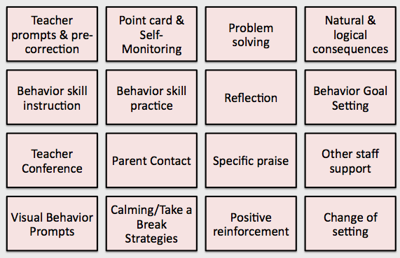

Moving from Tier 1 Interventions in a MTSS

- Classroom teachers use behavior management strategies to create a positive environment including teaching appropriate behaviors, reinforcing positive behaviors, giving specific praise, and prompting.
- When a student is not responsive to basic classroom behavior management, the teacher will utilize additional interventions, such as those listed above, to help shape behavior. The PBS team has made a commitment to be proactive and place as many Tier 1 behavior strategies in the hands of the teaching staff as possible.
- Teachers report the students who require these additional interventions for their classroom behaviors to the Behavior RTI team every week to be monitored for the possibility of requiring more intensive interventions and supports in the MTSS.
- In addition to the classroom behavior data, the Behavior RTI team also identifies students requiring additional support through ODR’s, reports from other settings, and direct contact information from the teacher, student, and parent.
- If the student does not respond to Tier 1 classroom level supports, the Behavior RTI Team will assign a case manager to provide additional intervention/support services in the MTSS.
- If appropriate, the Behavior RTI team may also conduct a student specific meeting at any time with involved staff and parents to determine if a student requires more support in the MTSS.

Sample Lesson Plan: Introduction to Growth Mindset - Third Grade

Activating Strategy:
-Show students a picture of a mountain.
-Ask, “If I asked if you could climb this mountain, what would you say?” “Why?”
-Elicit responses from students, recording their ideas on chart paper.

Vocabulary:
-Introduce the terms fixed mindset and growth mindset
Fixed Mindset: Intelligence and talent are both fixed at birth
Growth Mindset: Intelligence and talent can grow and change
-Discuss the idea that every time you learn something new, the brain forms new connections.

Show students the video, The Dot by: Peter Reynolds:
https://www.youtube.com/watch?v=t5mGeR4AQdM
-Tell students, “Let's watch this video about Vashti. As you watch it, think about her mindset. Is it fixed or growth? Does it change?”
-After the video, ask students to compare what Vashti learned to how they felt about the mountain.

Ask students to shout out “fixed mindset” or “growth mindset” as you say the following statements:
- I love a challenge
- Mistakes are our friends
- I can’t do this homework
- If I have to work hard, I am not very smart
- I was hoping this would be informative
- I’m jealous when other kids do well
- I made a mistake and can’t fix it
- I’m not good at writing
- I like to try new things
- This math is too hard

Discuss how mindsets impact us in school:
-Show students the following five fixed mindset statements and ask them to turn and talk with a partner to discuss which growth statement matches it as a better way to say it.

FIXED MINDSET STATEMENT | GROWTH STATEMENT
I don’t feel like doing anything today. | I’m ready to lead.
I messed up; I’m not doing this anymore. | I’m ready to care.
I’ll never be able to do this. | I’m ready to learn!
I hope I do better than everyone else. | I’m ready to try again.
I’m not helping anyone with this. | I’m ready to accept help.
Note: The growth statement next to the fixed is not the correct one; students should draw a line from the fixed statement to the growth statement.

Sample Lesson Plan: Introduction to Growth Mindset and our PBS School Rules
Third Grade
Introduce graphic with the school rules:
Be Ready to Learn
Be Ready to Try Again
Be Ready to Accept Help
Be Ready to Care
Be Ready to Lead

Discuss how each rule can apply to academics (how to grow as a “student”) and to behavior (how to grow to be a better friend and classmate).

Carousel activity:
-Materials: A poster prepared for each growth rule that has designated areas where students can give examples of their responses to how a student who is ready to learn is, does, says, and does not. Repeat for each rule.

Be Ready to Learn
Is | Does
Says | Does Not

-Tell students: When the poster for each rule is at your group table, write your responses to each question on a sticky note and place it on the poster. Be sure to use the growth mindset language we have learned. When the chimes ring, the group director will bring their poster to the next group. Each group will add to every poster, so there will be 5 rotations.
-Share final posters with the whole group. Display in classroom.

Summarizing Activity:
Have students fill out an exit ticket for the most important thing they learned about fixed/growth mindset and the new school rules.

Growth Mindset Children’s Books (online lessons available for several of these titles):
-Deak, J., & Ackerley, S. (2010). Your fantastic elastic brain: Stretch it, shape it.
-Saltzberg, B. (2010). Beautiful oops! New York: Workman Pub.
-Pett, M., & Rubinstein, G. (2011). The girl who never made mistakes. Naperville, Ill.: Sourcebooks Jabberwocky.
-Reynolds, P. (2003). The dot. Cambridge, Mass.: Candlewick Press.

