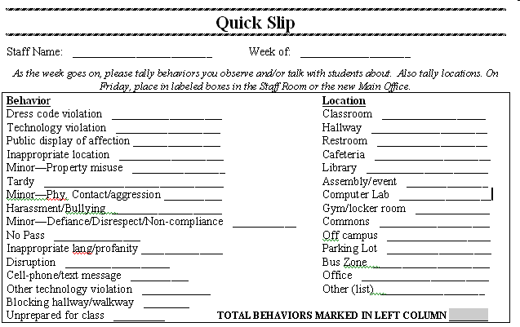

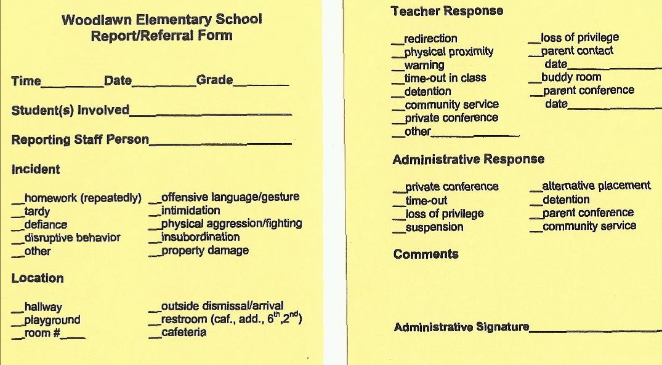

http://faculty.education.ufl.edu/Scott/Terrys/tscott.html