Delaware School Surveys Interpretation Worksheet
School Climate and Techniques

STAFF Version

Report Interpretation Key
Table Code by Scale |  | Table Code by Score Type
School Climate Scale – Table 1 |  | Standard Scores – Table a |  | Bold – Total Scores
Techniques Scale – Table 2 |  | Average Scores – Table b |  | Green – Favorable
 |  | Percentage Response Scores – Table c |  | Red – Unfavorable

 | Favorable (GREEN) |  | Unfavorable (RED)
Scale | Standard Score | Average Score | Standard Score | Average Score
School Climate & Techniques | 110 and above | 3.4 and above | 89 and below | 2.5 and below

Standard Score Distribution Average Item Score Calculation
Determine: Do your respondents’ scores reflect positive or negative perceptions of school climate, regardless of how your school compares to other schools?

Determine: How does your school compare to other like schools?

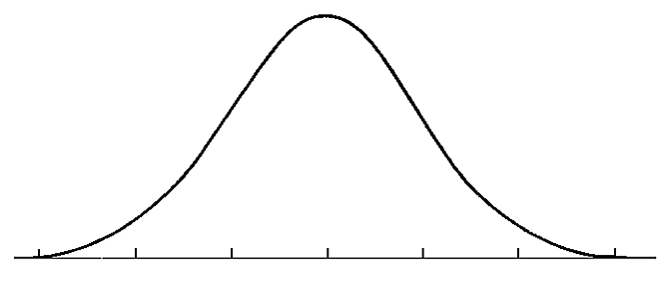
SS = 110
SS = 89
Considerable Sizeable
Concerns Strengths

Average scores are calculated by finding the average of all responses for each item.

Example:
Responses to Item 5 = 2,3,3,3,4,2
2+3+3+3+4+2= 17
17/6= 2.82
Average Item Score = 2.83

TEACHER/STAFF DATA REPORT
School Climate Scale – Table 1

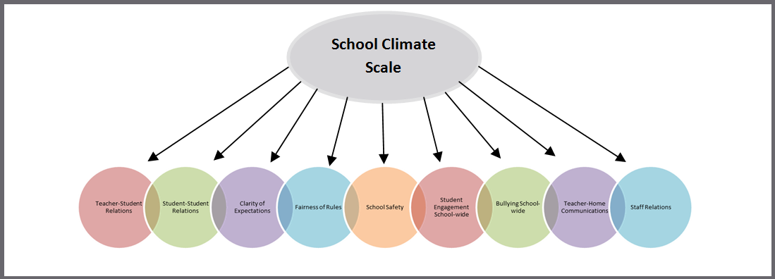

Response Scale: 1=Disagree A Lot 2=Disagree 3=Agree 4=Agree A Lot

AVERAGE ITEM SCORE (AIS): TRENDS REVIEW

Graph | Use to… | Ask yourself…
1b  School Climate  Average Score  Cross-Year Review | Note school’s average item scores per subscale for this school year and 2 previous years (if data are available). | By subscale and overall, have our average item scores per subscale increased, decreased, or maintained over the years?

Our Increased Areas | Our Decreased Areas | Our Maintained Areas
Additional Notes

Table | Use to… | Ask yourself…
1b  School Climate  Average Item Scores | Note the sizable strengths and considerable concerns for YOUR school. A score of 3 or above means that the respondents on average agree or agree a lot. Remember, lower scores are preferred for Bullying School-wide. | What areas are strengths for our school? What areas do we need to address? Are there differences within or between position groups? Do staff members view student relationships positively? Do staff members feel rules are clear and fair?

School Climate Scale Totals (AIS)
Our Strengths | Concerns to Address
Additional Notes

School Climate Scale by Position (AIS)
Our Strengths | Concerns to Address
Additional Notes

PERCENT RESPONSE SCORE: TRENDS REVIEW
Table | Use to… | Ask yourself…
1c  School Climate  Percentage Response Scores | Note individual items that caused scores to be low or high. By looking at this data, you can find out which items staff members feel strongly about and direct efforts accordingly. | Were there any individual items from a subscale that had particularly high or low response percentage? How did this impact our overall score? What can we do to address these focus areas?

Subscales | Our Strengths  (Item Numbers) | Concerns to Address  (Item Numbers)
Teacher-Student Relations
Student-Student Relations
Student Engagement School-wide
Clarity of Expectations
Fairness of Rules
School Safety
Bullying School-wide*
Teacher-Home Communications
Staff Relations
Additional Notes

*A high score on this subscale is negative because items are negatively worded

STANDARD SCORE (SS): TRENDS REVIEW

Table | Use to… | Ask yourself…
1a  School Climate  Standard Scores | Compare your school to other schools serving the same grade level (e.g. ES, MS, HS). A score of 100 is average, so in general, scores above 100 illustrate your school has higher scores than other same level schools. | What are our strengths and weaknesses compared to other schools that serve similar age students? Are there differences between and within position groups that we need to explore?

School Climate Scale Totals (SS)
Our Strengths | Concerns to Address
Additional Notes

School Climate by Position (SS)
Our Strengths | Concerns to Address
Additional Notes

TEACHER/STAFF DATA REPORT
Techniques Scale – Table 2

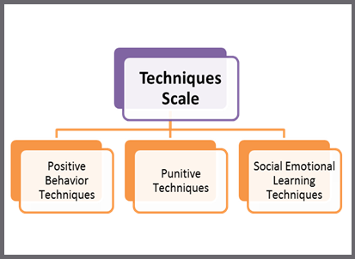

Response Scale: 1=Disagree A Lot 2=Disagree 3=Agree 4=Agree A Lot

AVERAGE ITEM SCORE (AIS): TRENDS REVIEW

Graph | Use to… | Ask yourself…
2b  Techniques  Average Scores  Cross-Year Review | Note your school’s average item scores per subscale for this school year and 2 previous years (if data are available). | By subscale and overall, have our average item scores per subscale increased, decreased, or maintained over the years?

Our Increased Areas | Our Decreased Areas | Our Maintained Areas
Additional Notes

Table | Use to… | Ask yourself…
2b  Techniques  Average Item Scores | Note the sizable strengths and considerable concerns for YOUR school. The scores are a measure of how staff members perceive the techniques used by their peers. An average score of 3 or above means that the respondents on average agree or agree a lot. | What areas are strengths for our school? What areas do we need to address? Are there differences within or between position groups? Do staff members acknowledge the positive techniques used by their peers? Do staff members feel that their peers are more negative than positive?

Techniques Scale Totals (AIS)
Our Strengths | Concerns to Address
Additional Notes

Techniques by Position (AIS)
Our Strengths | Concerns to Address
Additional Notes

PERCENT RESPONSE SCORE: TRENDS REVIEW

Table | Use to… | Ask yourself…
2c  Techniques  Percentage Response Scores | Note individual items that caused subscale scores to be low or high. By looking at this data, you can find out which items staff members feel strongly about and direct efforts accordingly. | Were there any individual items from a subscale that had particularly high or low response percentage? How did this impact our overall score? What can we do to address these focus areas?

Subscales | Our Strengths  (Item Numbers) | Concerns to Address  (Item Numbers)
Positive Techniques
Punitive Techniques*
SEL Techniques
Additional Notes

*A high score on this subscale is negative because items are negatively worded

STANDARD SCORE (SS): TRENDS REVIEW

Table | Use to… | Ask yourself…
2a  Techniques Standard Scores | Compare your school to other schools serving the same grade level (e.g. ES, MS, HS). A score of 100 is average, so in general, scores above 100 illustrate your school has higher scores than other same level schools. Remember, higher scores are preferred for positive techniques and SEL, and lower scores are better for punitive techniques. | What are our strengths and weaknesses compared to other schools that serve similar age students? Are there differences between and within groups position groups that we need to explore.

Techniques Scale Totals (SS)
Our Strengths | Concerns to Address
Additional Notes

Techniques by Position (SS)
Our Strengths | Concerns to Address
Additional Notes

