How to: ABC Data Collection Tool

What’s it for?
The ABC data collection tool is a data sheet that can be used to help track specific behaviors across settings and days. By tracking day of the week, context, antecedent, and consequence, patterns can be drawn about a student’s specific behavior over time to make informed decisions.

How do I interpret it?
A few questions that might be helpful to ask when looking at data in the ABC data collection tool are:
- Is there a pattern based on time of day or day of the week?
- Is there a pattern based on the context or antecedent?
- Are the antecedents related to particular behaviors?
- Do we have enough information about each behavior?
- Are specific behaviors more often paired with certain consequences?
- Are some consequences more effective than others for a certain behavior?

How do I use the data sheet?
- The first thing to do is mark down which specific behavior is observed with this data at the top. Double-click on the <insert definition> text to edit it.
- Next, begin inputting data by finding the correct count category (i.e., day of the week) and input that information.
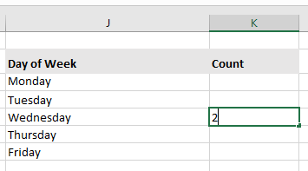
- After pressing enter or clicking away to confirm input for each category, that information will automatically be processed into the respective count graph.
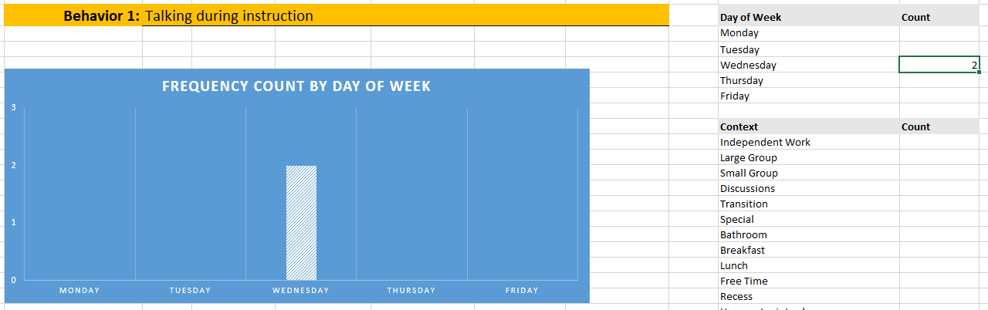
- Continue filling out the sheet and other count categories with the data you have on this particular behavior.
- If you need to fill out another sheet for another behavior by the student, there are three sheets pre-loaded into the document at the bottom bar of Excel that may be switched between.

How can I measure more than three behaviors for a student?
- In order to make additional behavior tabs, the data template needs to be copied.
- Right click on the last tab (making sure it is NOT filled out yet or that you manually remove the copied data in the new file) and select Move or Copy.
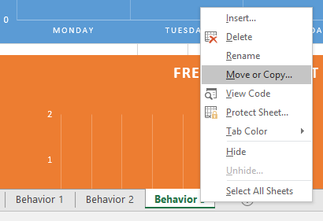
- In the dialogue box that pops up, select (move to end) and make sure to check Create a copy at the bottom of the box.
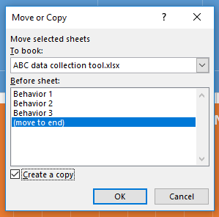

- A copy of the last sheet has now been created! The last part is to rename the labeling of the file to Behavior #, depending on what tab it comes after. This can be done by right-clicking the new tab at the bottom and selecting Rename.
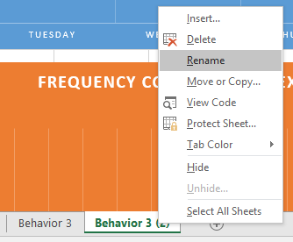
- Additionally, you may want to rename the Behavior label at the top of the file to match the tabs below. To do this, click on the Behavior cell and change the number next to it.
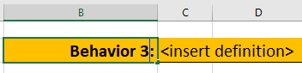

How can I add a category not listed?
- If a certain context, antecedent, or so forth that you’ve collected data on is not an option in the file, you can edit the Other option under most count categories to enter your own.
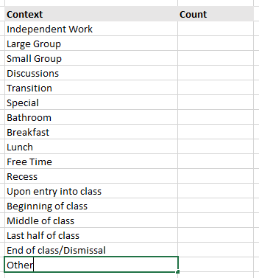
- After editing the Other category and pressing enter or clicking away, the tab on the count graph will automatically update and replace the original Other category.
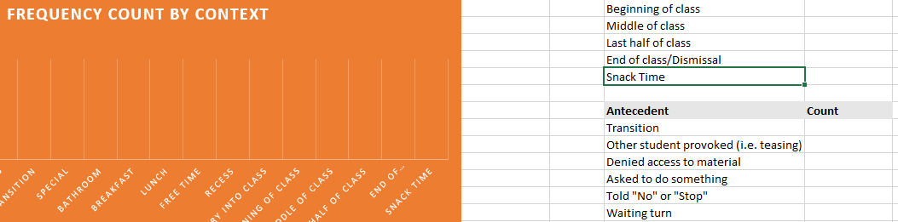

How to find average number of incidents per day
- Another feature of the ABC data collection sheet is the ability to find out the average number of incidents per day across the observed period.
- Scroll to the right of the data sheet to find a separate group of entry points that starts with Total Days of Data Collection.
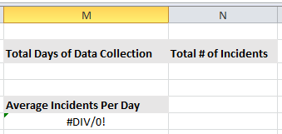
- Enter in the number of days of observation and the total number of incidents observed over this time period. Do NOT enter anything into the average incidents category.
- The Average Incidents number will be calculated automatically by the sheet once the two scores above are entered and the final product should look like this:
