Delaware School Surveys Interpretation Worksheet
School Climate, Techniques, Bullying,
Engagement, Social Emotional Competencies

STUDENT Version

Report Interpretation Key
Table Code by Scale |  | Table Code by Score Type
School Climate Scale – Table 1 |  | Standard Scores – Table a |  | Bold – Total Scores
Techniques Scale – Table 2 |  | Average Scores – Table b |  | Green – Favorable
Bullying Scale – Table 3 |  | Percentage Response Scores – Table c |  | Red – Unfavorable
Engagement Scale – Table 4

Social Emotional Competencies – Table 5

 | Favorable (GREEN) |  | Unfavorable (RED)
Scale | Standard Score | Average Score | Standard Score | Average Score
School Climate, Techniques, Engagement, & Social Emotional Competencies Scales | 110 and above | 3.4 and above | 89 and below | 2.5 and below
Bullying Scale | N/A | N/A | 110 and above | 3.0 and above

Standard Score Distribution Average Item Score Calculation
Determine: Do your respondents’ scores reflect positive or negative perceptions of school climate, regardless of how your school compares to other schools?

Determine: How does your school compare to other like schools?

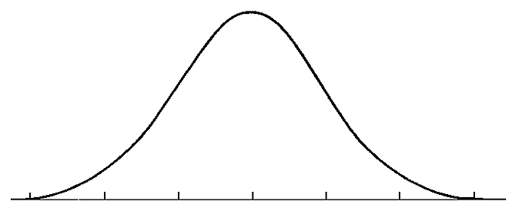
SS = 110
SS = 89
Considerable Sizeable
Concerns Strengths

Average scores are calculated by finding the average of all responses for each item.

Example:
Responses to Item 5 = 2,3,3,3,4,2
2+3+3+3+4+2= 17
17/6= 2.82
Average Item Score = 2.83

STUDENT DATA REPORT
School Climate Scale – Table 1

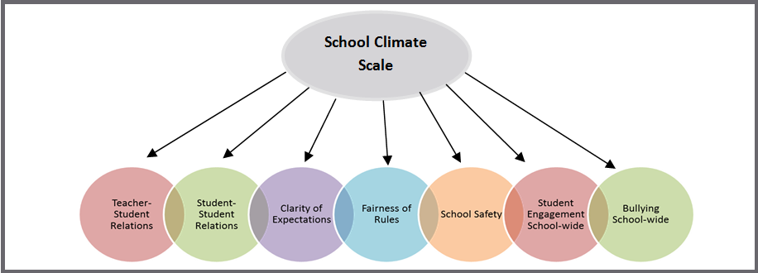

Response Scale: 1=Disagree A Lot 2=Disagree 3=Agree 4=Agree A Lot

AVERAGE ITEM SCORE (AIS): TRENDS REVIEW

Graph | Use to… | Ask yourself…
1b  School Climate  Average Score  Cross-Year Review | Note school’s average item scores per subscale for this school year and 2 previous years (if data are available). | By subscale and overall, have our average item scores per subscale increased, decreased, or maintained over the years?

Our Increased Areas | Our Decreased Areas | Our Maintained Areas
Additional Notes

Table | Use to… | Ask yourself…
1b  School Climate  Average Item Scores | Note the sizable strengths and considerable concerns for YOUR school. A score of 3 or above means that the respondents on average agree or agree a lot. Remember, lower scores are preferred for Bullying School-wide. | What areas are strengths for our school? What areas do we need to address? Are there differences within or between grade, race or gender groups? Do students view peer relationships positively? Do students feel rules are clear and fair?

School Climate Scale Totals (AIS)
Our Strengths | Concerns to Address
Additional Notes

School Climate Scale by Race/Gender/Grade (AIS)
Our Strengths | Concerns to Address
Additional Notes

PERCENT RESPONSE SCORE: TRENDS REVIEW

Table | Use to… | Ask yourself…
1c  School Climate  Percentage Response Scores | Note individual items that caused scores to be low or high. By looking at this data, you can find out which items students feel strongly about and direct efforts accordingly. | Were there any individual items from a subscale that had particularly high or low response percentage? How did this impact our overall score? What can we do to address these focus areas?

Subscales | Our Strengths  (Item Numbers) | Concerns to Address  (Item Numbers)
Teacher-Student Relations
Student-Student Relations
Student Engagement School-wide
Clarity of Expectations
Fairness of Rules
School Safety
Bullying School-wide*
Additional Notes

*A high score on this subscale is negative because items are negatively worded

STANDARD SCORE (SS): TRENDS REVIEW

Table | Use to… | Ask yourself…
1a (1)(2)  School Climate  Standard Scores | Compare your school to other schools serving the same grade level (e.g. ES, MS, HS). A score of 100 is average, so in general, scores above 100 illustrate your school has higher scores than other same level schools. | What are our strengths and weaknesses compared to other schools that serve similar age students? Are there differences between and within groups (grade, race, gender) that we need to explore?

School Climate Scale Totals (SS)
Our Strengths | Concerns to Address
Additional Notes

School Climate by Race/Gender/Grade (SS)
Our Strengths | Concerns to Address
Additional Notes

STUDENT DATA REPORT
Techniques Scale – Table 2
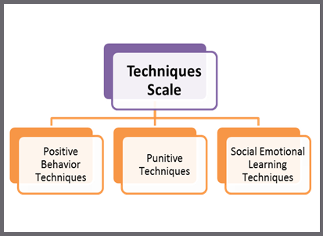
Response Scale: 1=Disagree A Lot 2=Disagree 3=Agree 4=Agree A Lot

AVERAGE ITEM SCORE (AIS): TRENDS REVIEW

Graph | Use to… | Ask yourself…
2b  Techniques  Average Scores Cross-Year Review | Note your school’s average item scores per subscale for this school year and 2 previous years (if data are available). | By subscale and overall, have our average item scores per subscale increased, decreased, or maintained over the years?

Our Increased Areas | Our Decreased Areas | Our Maintained Areas
Additional Notes

Table | Use to… | Ask yourself…
2b  Techniques  Average Item Scores | Note the sizable strengths and considerable concerns for YOUR school. The scores are a measure of how the students perceive the techniques used by the staff. An average score of 3 or above means that the respondents on average agree or agree a lot. | What areas are strengths for our school? What areas do we need to address? Are there differences within or between grade, race, or gender groups? Do the students acknowledge the positive techniques used by staff? Do the students feel that staff is more negative than positive?

Techniques Scale Totals (AIS)
Our Strengths | Concerns to Address
Additional Notes

Techniques Scale by Race/Gender/Grade (AIS)
Our Strengths | Concerns to Address
Additional Notes

PERCENT RESPONSE SCORE: TRENDS REVIEW

Table | Use to… | Ask yourself…
2c  Techniques  Percentage Response Scores | Note individual items that caused subscale scores to be low or high. By looking at this data, you can find out which items students feel strongly about and direct efforts accordingly. | Were there any individual items from a subscale that had particularly high or low response percentage? How did this impact our overall score? What can we do to address these focus areas?

Subscales | Our Strengths  (Item Numbers) | Concerns to Address  (Item Numbers)
Positive Techniques
Punitive Techniques*
SEL Techniques
Additional Notes

*A high score on this subscale is negative because items are negatively worded

STANDARD SCORE (SS): TRENDS REVIEW

Table | Use to… | Ask yourself…
2a (1) (2) Techniques Standard Scores | Compare your school to other schools serving the same grade level (e.g. ES, MS, HS). A score of 100 is average, so in general, scores above 100 illustrate your school has higher scores than other same level schools. Remember, higher scores are preferred for positive techniques and SEL, and lower scores are better for punitive techniques. | What are our strengths and weaknesses compared to other schools that serve similar age students? Are there differences between and within groups (grade, race, gender) that we need to explore.

Techniques Scale Totals (SS)
Our Strengths | Concerns to Address
Additional Notes

Techniques by Race/Gender/Grade (SS)
Our Strengths | Concerns to Address
Additional Notes

STUDENT DATA REPORT
Bullying Scale* – Table 3
*A high score on this scale is negative because items are negatively worded

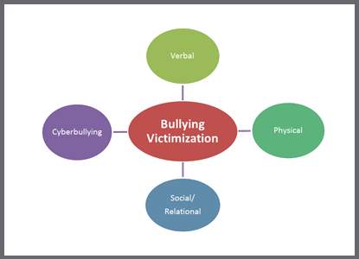

Response Scale: 1= Never 2=Less than once a month 3=Once or twice a month
4=Once a week 5= Several times a week 6= Every day

AVERAGE ITEM SCORE (AIS): TRENDS REVIEW

Graph | Use to… | Ask yourself…
3b  Bullying  Average Scores Cross-Year Review | Note school’s average item scores per subscale for this school year and 2 previous years (if data are available). | By subscale and overall, have our average item scores per subscale increased, decreased, or maintained over the years?

Our Increased Areas |  |  | Our Decreased Areas |  | Our Maintained Areas
Additional Notes

 | Table | Use to… |  | Ask yourself…
 | 3b  Bullying  Average Item Scores | Note the sizable strengths and considerable concerns for YOUR school. Explore students’ perceptions of the frequency of what types of bullying occur in the school. Keep in mind, lower scores are better. |  | What areas are strengths for our school? What areas do we need to address? Are there grade, race, or gender differences to explore? Are there differences in what types of bullying students perceive as a problem in your school? Do students see physical bullying as occurring more often than verbal?

Bullying Scale Totals (AIS)
Our Strengths | Concerns to Address
Additional Notes

Bullying by Race/Gender/Grade (AIS)
Our Strengths | Concerns to Address
Additional Notes

PERCENT RESPONSE SCORE: TRENDS REVIEW

Table | Use to… | Ask yourself…
3c  Bullying  Percentage Response Scores | Review students’ responses to the individual questions. Note individual items that caused subscale scores to be low or high. By looking at this data, you can identify items students note as occurring more or less frequently. | Were there any individual items from a subscale that had particularly high or low response percentage? How did this impact our overall score? What can we do to address these focus areas?

Subscales | Our Strengths  (Item Numbers) | Concerns to Address  (Item Numbers)
Verbal Bullying
Physical Bullying
Social/Relational Bullying
Cyberbullying
(6th-12th grade only)
Additional Notes

STANDARD SCORE (SS): TRENDS REVIEW

Table | Use to… | Ask yourself…
3a (1) (2)  Bullying  Standard Scores | Compare your school to other schools serving the same grade level (e.g., ES, MS, HS). A score of 100 is average, so in general, scores above 100 illustrate your school has higher scores than other same level schools. Use these scores to determine what kinds of bullying students identify as a problem in relation to similar schools. Remember that low scores are preferred. | What are our strengths and weaknesses compared to other schools that serve similar age students? Are there differences between and within groups (grade, race, gender) that we need to explore? Are some standard scores higher? Why?

Bullying Scale Totals (SS)
Our Strengths | Concerns to Address
Additional Notes

Bullying by Race/Gender/Grade (SS)
Our Strengths | Concerns to Address
Additional Notes

STUDENT DATA REPORT
Engagement Scale – Table 4

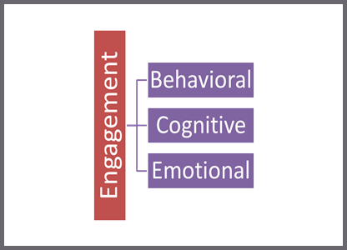

Response Scale: 1=Disagree A Lot 2=Disagree 3=Agree 4=Agree A Lot

AVERAGE ITEM SCORE (AIS): TRENDS REVIEW

Graph | Use to… | Ask yourself…
4b  Engagement  Average Scores Cross-Year Review | Note school’s average item scores per subscale for this school year and 2 previous years (if data are available). | By subscale and overall, have our average item scores per subscale increased, decreased, or maintained over the years?

Our Increased Areas | Our Decreased Areas | Our Maintained Areas
Additional Notes

Table | Use to… | Ask yourself…
4b  Engagement  Average Item Scores | Note the sizable strengths and considerable concerns for YOUR school. A score of 3 or above means that the respondents on average agree or agree a lot. | What areas are strengths for our school? What areas do we need to address? Are there differences within or between grade, race or gender groups? Do our students report being more cognitively, behaviorally, or emotionally engaged?

Engagement Scale Totals (AIS)
Our Strengths | Concerns to Address
Additional Notes

Engagement by Race/Gender/Grade (AIS)
Our Strengths | Concerns to Address
Additional Notes

PERCENT RESPONSE SCORE: TRENDS REVIEW

Table | Use to… | Ask yourself…
4c  Engagement  Percentage Response Scores | Note individual items that caused subscale scores to be low or high. By looking at this data, you can find out which items students feel strongly about and direct efforts accordingly. | Were there any individual items from a subscale that had particularly high or low response percentage? How did this impact our overall score? What can we do to address these focus areas?

Subscales | Our Strengths  (Item Numbers) | Concerns to Address  (Item Numbers)
Cognitive Engagement
Behavioral Engagement
Emotional Engagement
Additional Notes

STANDARD SCORE (SS): TRENDS REVIEW

Table | Use to… | Ask yourself…
4a (1) (2)  Engagement Standard Scores | Compare your school to other schools serving the same grade level (e.g. ES, MS, HS). A score of 100 is average, so in general, scores above 100 illustrate your school has higher scores than other same level schools. | What are our strengths and weaknesses compared to other schools that serve similar age students? Are there differences between and within groups (grade, race, gender) that we need to explore?

Engagement Scale Totals (SS)
Our Strengths | Concerns to Address
Additional Notes

Engagement by Race/Gender/Grade (SS)
Our Strengths | Concerns to Address
Additional Notes

STUDENT DATA REPORT
Social and Emotional Competencies Scale – Table 5

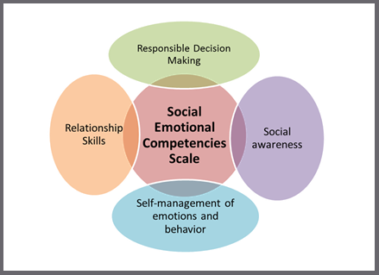
*Note: This SEC scale does not have subscales, but these 4 concepts are reflected in the items.

Response Scale: 1 = Not like me at all, 2 = Not much like me, 3 = Somewhat like me, 4 = Very much like me

AVERAGE ITEM SCORE (AIS) REVIEW

Graph | Use to… | Ask yourself…
5b  Social Emotional Competencies  Average Scores Cross-Year Review | Note school’s average item total score for this school year and last year (if data is available). | Has our total average item score increased, decreased, or maintained since last year?

Our Increased Areas | Our Decreased Areas | Our Maintained Areas
Additional Notes

Table | Use to… | Ask yourself…
5b  Social Emotional Competencies  Average Item Scores | Note the sizable strengths and considerable concerns for YOUR school. A score of 3 or above means that the students on average feel the statement is somewhat or very much like them. | Is this an area of strength or concern for our school? Are there differences between grade, race or gender groups?

Social Emotional Competencies Scale Totals & by Race/Gender/Grade (AIS)
Our Strengths | Concerns to Address
Additional Notes

PERCENT RESPONSE SCORE: TRENDS REVIEW

Table | Use to… | Ask yourself…
5c  Social Emotional Competencies  Percentage Response Scores | Note individual items that caused the total score to be low or high. By looking at this data, you can find out which items students self-identify with and direct efforts accordingly. These data are organized by the 4 concepts within the scale. | Were there any individual items from that had a particularly high or low response percentage? How did this impact our overall score? What can we do to address these focus areas?

Social Emotional Competencies  Scale Concepts | Our Strengths  (Item Numbers) | Concerns to Address  (Item Numbers)
Responsible Decision Making
Social Awareness
Self-management of
Emotions & Behavior
Relationship Skills
Additional Notes

STANDARD SCORE (SS): TRENDS REVIEW

Table | Use to… | Ask yourself…
5a  Social Emotional Competencies Standard Scores | Compare your school to other schools at the same grade level (e.g., ES, MS, HS). A score of 100 is average, so in general, scores above 100 mean your school has higher scores than other same level schools. | What are our strengths and weaknesses compared to other schools that serve similar age students? Are there differences between groups (grade, race, gender) that we need to explore?

Social and Emotional Competencies Scale Totals & by Race/Gender/Grade (SS)
Our Strengths | Concerns to Address
Additional Notes

