Notes Page for
Defusing High School Student Fights Through Tier 1 and 2 Innovations
2019 Northeast PBIS Leadership Forum
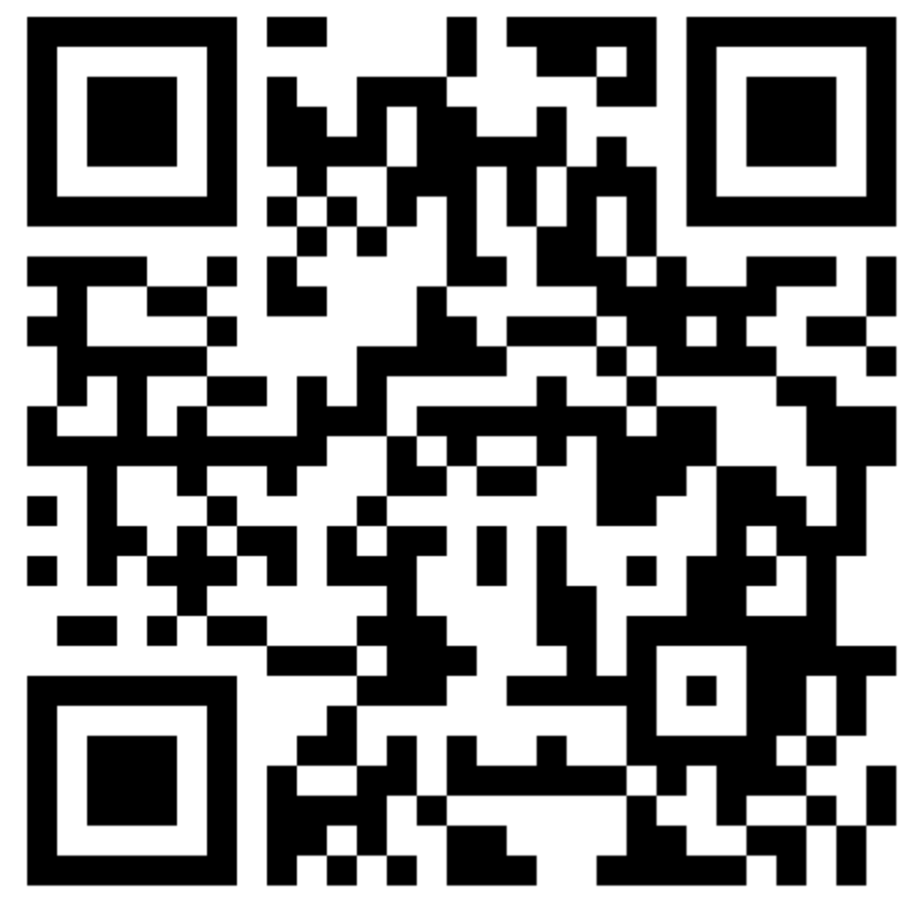
Let’s Make This Interactive!
Padlet
https://padlet.com/mpell2/dq9m0eo8lplk
- Please post if you have Questions for Presenters
- Please post if you have Related Methods/Tools to Share with Others

Our Contact Information
- Courtney.voshell@capital.k12.de.us | - Melissa.Butz@capital.k12.de.us
- Caroline.Green@capital.k12.de.us | - Megan.Pell@udel.edu
- Delawarepbs.org

Some of the Topics To Be Covered!

- Tier 1 | - Data-Based Decision-Making | - Multi-Tiered System of Support (MTSS) | - Reintegrative and Restorative Practices
- Tier 2 | - Social Emotional Learning | - Student Voice | - Sustainability

Space for Your Notes!

