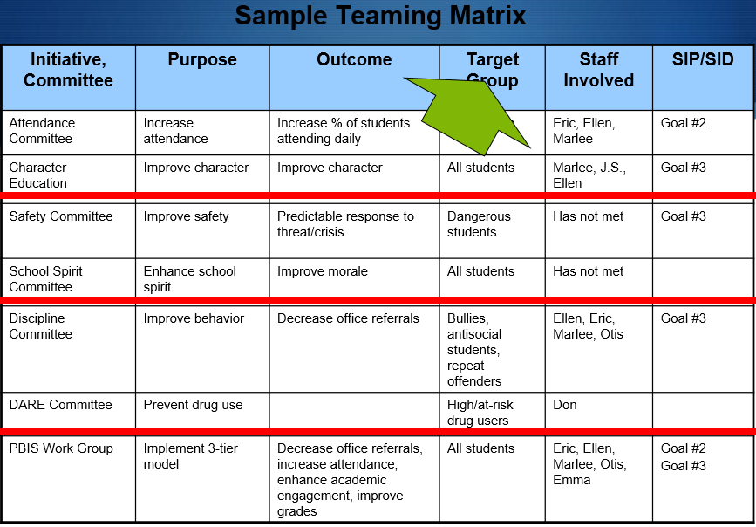

When you can’t measure it – how can you gauge usefulness?

Sample from PBIS.org

Sample Working Smarter

Do you have staff as a target group?

What does this mean if they haven’t met?