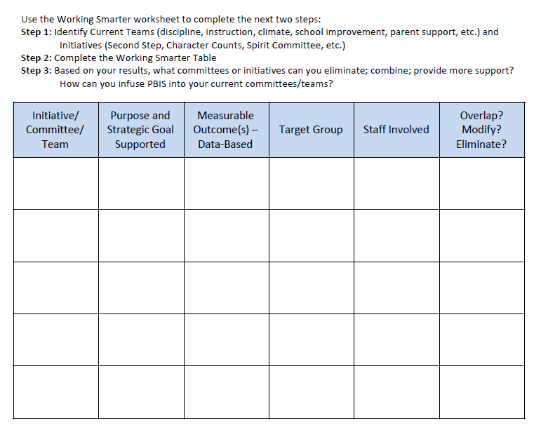
Working Smarter
From: Midwest PBIS Tier 1 Team PBIS Action Planning Workbook v11-26-2018

