ISF Initiative Inventory (Adopted from NIRN Initiative Inventory)
Purpose of this tool is to (a) provide an overall picture of existing social emotional behavioral related initiatives or programs available to the larger community, (b) determine the effectiveness, relevance, and fidelity for each, (c) determine funding and resource allocation, and (d) determine areas of redundancy. This process is led by the District/Building Leadership Team with representation from both education and community stakeholders.

Name of Initiative | What is connection to Leadership Team mission? | What personnel are involved in the implementation? | What is expected outcome? | What evidence of outcomes are there thus far? | What is financial commitment and source of funding? | What fidelity measures exist? | What professional development exists including coaching and performance feedback?

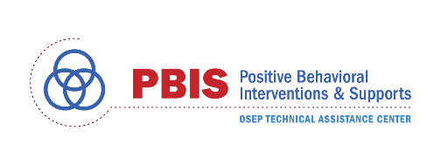
This work is supported by grant SM081726 from the Department of Health and Human Services, Substance Abuse and Mental Health Services Administration, and was supported from funds provided by the Center on Positive Behavioral Interventions and Supports cooperative grant supported by the Office of Special Education Programs (OSEP) of the U.S. Department of Education (H326S180001). Dr. Renee Bradley served as the project officer.

