Delaware School Surveys Interpretation Worksheet
School Climate, Techniques, Bullying,
Engagement, Social Emotional Competencies

STUDENT Version
Report Interpretation Key
Scales |  |  | Score Type |  | Color Codes
School Climate Scale |  |  | Average Scores |  | Bold – Total Scores
Techniques Scale |  |  | Percentage Response Scores |  | Green – Favorable
Bullying Scale |  |  | Standard Scores |  | Red – Unfavorable
Engagement Scale

Social Emotional Competencies

 | Favorable (GREEN) |  | Unfavorable (RED)
Scale | Standard Score | Average Item Score | Standard Score | Average Item Score
School Climate, Techniques, Engagement, & Social Emotional Competencies Scales | 110 and above | 3.2 and above | 89 and below | 2.5 and below
School Climate – Bullying SW | 89 and below | 2.0 and below | 110 and above | 3.0 and above
Techniques – Punitive Techniques | 89 and below | 2.0 and below | 110 and above | 3.0 and above
Bullying Scale | N/A | N/A | 110 and above | 3.0 and above

Standard Score Distribution Average Item Score Calculation
Determine: Do your respondents’ scores reflect positive or negative perceptions of school climate, regardless of how your school compares to other schools?
Determine: How does your school compare to other like schools?

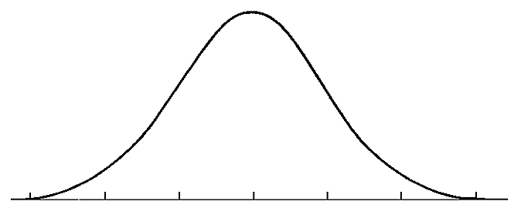

Average scores are calculated by finding the average of all responses for each item.

Example:
Responses to Item 5 = 2,3,3,3,4,2
2+3+3+3+4+2= 17
17/6= 2.82
Average Item Score = 2.83
SS = 110
SS = 89

Considerable Sizeable
Concerns Strengths
Determine: How does one know if differences in scores are significant? See pg. 4 of report
STUDENT DATA REPORT
School Climate Scale

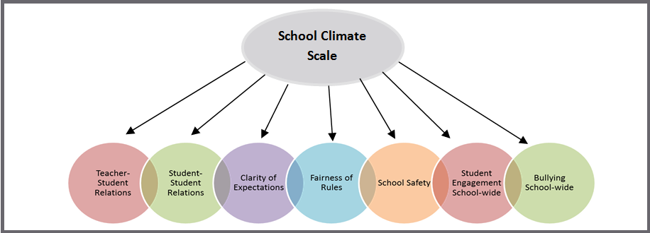

Response Scale: 1=Disagree A Lot 2=Disagree 3=Agree 4=Agree A Lot

Average Item Score Comparison – School Climate Scale BAR GRAPH (pg. 5)

*Note: Current year data is represented in BLUE
Graph | Use to… | Ask yourself…
Average Item Score Comparison – School Climate Scale  (Cross-Year Review) | Note school’s average item scores per subscale for this school year and 2 previous years (if data are available). | By subscale and overall, have our average item scores per subscale increased, decreased, or maintained over the years?

Our Increased Areas | Our Decreased Areas | Our Maintained Areas
Additional Notes

Average Item Score Comparison – School Climate Scale TABLE (pg. 6-7)

Table | Use to… | Ask yourself…
School Climate  Average Item Scores for All Grades Combined | Note the sizable strengths and considerable concerns for YOUR school. A score of 3 or above means that the respondents on average agree or agree a lot. Remember, lower scores are preferred for Bullying School-wide. | What areas are strengths for our school? What areas do we need to address? Are there differences within or between grade, race or gender groups? Do students view peer relationships positively? Do students feel rules are clear and fair?

School Climate Average Item Score Totals
Our Strengths | Concerns to Address
Additional Notes

School Climate Average Item Score by Grade/Gender/Ethnicity
Our Strengths | Concerns to Address
Additional Notes

School Climate Individual Item Responses (pg. 8-9)

Table | Use to… | Ask yourself…
School Climate  Individual Item Responses  (Percentage Response Scores) | Note individual items that caused scores to be low or high. By looking at this data, you can find out which items students feel strongly about and direct efforts accordingly. | Were there any individual items from a subscale that had a particularly high or low response percentage? How did this impact our overall score? What can we do to address these focus areas?

Subscales | Our Strengths | Concerns to Address
Teacher-Student Relations
Student-Student Relations
Student Engagement School-wide
Clarity of Expectations
Fairness of Rules
School Safety
Bullying School-wide*
Additional Notes

*A high score on this subscale is negative because items are negatively worded.

School Climate Standard Score TABLE (pg. 10-11)

Table | Use to… | Ask yourself…
School Climate  Standard Scores Compared with Other Participating Schools | Compare your school to other schools serving the same grade level (e.g. ES, MS, HS). A score of 100 is average, so in general, scores above 100 illustrate your school has higher scores than other same level schools. Remember, lower scores are preferred for Bullying School-wide. | What are our strengths and weaknesses compared to other schools that serve similar age students? Are there differences between and within groups (grade, gender, ethnicity) that we need to explore?

School Climate Scale Totals
Our Strengths | Concerns to Address
Additional Notes

School Climate Standard Scores by Grade/Gender/Ethnicity
Our Strengths | Concerns to Address
Additional Notes

STUDENT DATA REPORT
Techniques Scale
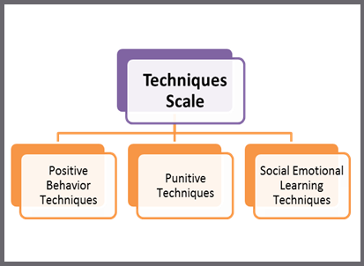
Response Scale: 1=Disagree A Lot 2=Disagree 3=Agree 4=Agree A Lot

Average Item Score Comparison – Techniques Scale BAR GRAPH (pg. 12)

*Note: Current year data is represented in BLUE
Graph | Use to… | Ask yourself…
Average Item Score Comparison – Techniques Scale (Cross-Year Review) | Note your school’s average item scores per subscale for this school year and 2 previous years (if data are available). | By subscale and overall, have our average item scores per subscale increased, decreased, or maintained over the years?

Our Increased Areas | Our Decreased Areas | Our Maintained Areas
Additional Notes

Average Item Score Comparison – Techniques Scale TABLE (pg. 12-13)

Table | Use to… | Ask yourself…
Techniques  Average Item Scores for All Grades Combined | Note the sizable strengths and considerable concerns for YOUR school. The scores are a measure of how the students perceive the techniques used by the staff. An average score of 3 or above means that the respondents on average agree or agree a lot. Remember, lower scores are preferred for Punitive Techniques. | What areas are strengths for our school? What areas do we need to address? Are there differences within or between grade, gender, or ethnicity groups? Do the students acknowledge the positive techniques used by staff? Do the students feel that staff is more negative (punitive) than positive?

Techniques Average Item Score Totals
Our Strengths | Concerns to Address
Additional Notes

Techniques Scale by Grade/Gender/Ethnicity
Our Strengths | Concerns to Address
Additional Notes
Techniques Individual Item Responses (pg. 14-15)

Table | Use to… | Ask yourself…
Techniques Individual Item Responses  (Percentage Response Scores) | Note individual items that caused subscale scores to be low or high. By looking at this data, you can find out which items students feel strongly about and direct efforts accordingly. | Were there any individual items from a subscale that had particularly high or low response percentage? How did this impact our overall score? What can we do to address these focus areas?

Subscales | Our Strengths | Concerns to Address
Positive Techniques
Punitive Techniques*
SEL Techniques
Additional Notes

*A high score on this subscale is negative because items are negatively worded.

Techniques Standard Score TABLE (pg. 15-16)

Table | Use to… | Ask yourself…
Techniques Standard Scores Compared with Other Participating Schools | Compare your school to other schools serving the same grade level (e.g. ES, MS, HS). A score of 100 is average, so in general, scores above 100 illustrate your school has higher scores than other same level schools. Remember, higher scores are preferred for positive techniques and SEL, and lower scores are better for punitive techniques. | What are our strengths and weaknesses compared to other schools that serve similar age students? Are there differences between and within groups (grade, race, gender) that we need to explore?

Techniques Scale Totals
Our Strengths | Concerns to Address
Additional Notes

Techniques by Grade/Gender/Ethnicity
Our Strengths | Concerns to Address
Additional Notes

STUDENT DATA REPORT
Bullying Scale*
*A high score on this scale is negative because items are negatively worded

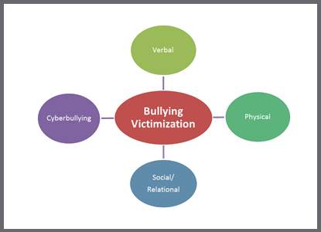
Response Scale: 1= Never 2=Less than once a month 3=Once or twice a month
4=Once a week 5= Several times a week 6= Every day

Average Item Score Comparison – Bullying Scale BAR GRAPH (pg. 17)

*Note: Current year data is represented in BLUE
Graph | Use to… | Ask yourself…
Average Item Score Comparison – Bullying Scale (Cross-Year Review) | Note school’s average item scores per subscale for this school year and 2 previous years (if data are available). | By subscale and overall, have our average item scores per subscale increased, decreased, or maintained over the years?

Our Increased Areas | Our Decreased Areas | Our Maintained Areas
Additional Notes

Average Item Score Comparison – Bullying Scale TABLE (pg. 18-19)

Table | Use to… | Ask yourself…
Bullying  Average Item Scores for All Grades Combined | Note the sizable strengths and considerable concerns for YOUR school. Explore students’ perceptions of the frequency of what types of bullying occur in the school. Keep in mind, lower scores are better. | What areas are strengths for our school? What areas do we need to address? Are there grade, race, or gender differences to explore? Are there differences in what types of bullying students perceive as a problem in your school? Do students see physical bullying as occurring more often than verbal?

Bullying Average Item Score Totals
Our Strengths | Concerns to Address
Additional Notes

Bullying by Grade/Gender/Ethnicity
Our Strengths | Concerns to Address
Additional Notes
Bullying Individual Item Responses (pg. 20-21)

Table | Use to… | Ask yourself…
Bullying Individual Item Responses  (Percentage Response Scores) | Review students’ responses to the individual questions. Note individual items that caused subscale scores to be low or high. By looking at this data, you can identify items students note as occurring more or less frequently. | Were there any individual items from a subscale that had particularly high or low response percentage? How did this impact our overall score? What can we do to address these focus areas?

Subscales | Our Strengths | Concerns to Address
Verbal Bullying
Physical Bullying
Social/Relational Bullying
Cyberbullying
(6th-12th grade only)
Additional Notes

Bullying Standard Score TABLE (pg. 21 and/or 22)

Table | Use to… | Ask yourself…
Bullying  Standard Scores Compared with Other Participating Schools | Compare your school to other schools serving the same grade level (e.g., ES, MS, HS). A score of 100 is average, so in general, scores above 100 illustrate your school has higher scores than other same level schools. Use these scores to determine what kinds of bullying students identify as a problem in relation to similar schools. Remember that low scores are preferred. | What are our strengths and weaknesses compared to other schools that serve similar age students? Are there differences between and within groups (grade, gender, ethnicity) that we need to explore? Are some standard scores higher? Why?

Bullying Scale Totals
Our Strengths | Concerns to Address
Additional Notes

Bullying by Grade/Gender/Ethnicity
Our Strengths | Concerns to Address
Additional Notes

STUDENT DATA REPORT
Engagement Scale

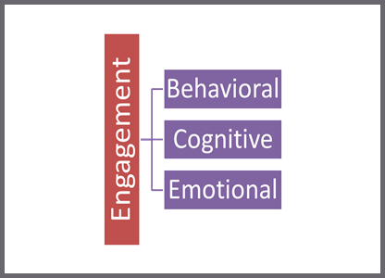

Response Scale: 1=Disagree A Lot 2=Disagree 3=Agree 4=Agree A Lot

Average Item Score Comparison – Engagement Scale BAR GRAPH (pg. 23)

*Note: Current year data is represented in BLUE
Graph | Use to… | Ask yourself…
Average Item Score Comparison – Engagement Scale (Cross-Year Review) | Note school’s average item scores per subscale for this school year and 2 previous years (if data are available). | By subscale and overall, have our average item scores per subscale increased, decreased, or maintained over the years?

Our Increased Areas | Our Decreased Areas | Our Maintained Areas
Additional Notes

Average Item Score Comparison – Engagement Scale TABLE (pg. 23-24)

Table | Use to… | Ask yourself…
Engagement  Average Item Scores for All Grades Combined | Note the sizable strengths and considerable concerns for YOUR school. A score of 3 or above means that the respondents on average agree or agree a lot. | What areas are strengths for our school? What areas do we need to address? Are there differences within or between grade, race or gender groups? Do our students report being more cognitively, behaviorally, or emotionally engaged?

Engagement Average Item Score Totals
Our Strengths | Concerns to Address
Additional Notes

Engagement by Grade/Gender/Ethnicity
Our Strengths | Concerns to Address
Additional Notes

Engagement Individual Item Responses (pg. 25)

Table | Use to… | Ask yourself…
Engagement Individual Item Responses  (Percentage Response Scores) | Note individual items that caused subscale scores to be low or high. By looking at this data, you can find out which items students feel strongly about and direct efforts accordingly. | Were there any individual items from a subscale that had particularly high or low response percentage? How did this impact our overall score? What can we do to address these focus areas?

Subscales | Our Strengths | Concerns to Address
Cognitive Engagement
Behavioral Engagement
Emotional Engagement
Additional Notes

Engagement Standard Score TABLE (pg. 25 and/or 26)

Table | Use to… | Ask yourself…
Engagement Standard Scores Compared with Other Participating Schools | Compare your school to other schools serving the same grade level (e.g. ES, MS, HS). A score of 100 is average, so in general, scores above 100 illustrate your school has higher scores than other same level schools. | What are our strengths and weaknesses compared to other schools that serve similar age students? Are there differences between and within groups (grade, gender, ethnicity) that we need to explore?

Engagement Scale Totals
Our Strengths | Concerns to Address
Additional Notes

Engagement by Grade/Gender/Ethnicity
Our Strengths | Concerns to Address
Additional Notes

STUDENT DATA REPORT
Social and Emotional Competencies Scale

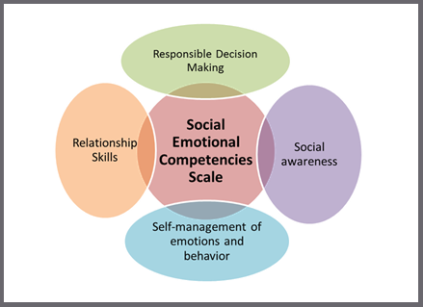
Response Scale: | 1 = Not like me at all, 2 = Not much like me, 3 = Somewhat like me, 4 = Very much like me

Average Item Score Comparison – Social Emotional Competencies BAR GRAPH

*Note: Current year data is represented in BLUE
Graph | Use to… | Ask yourself…
Average Item Score Comparison – Social Emotional Competences (Cross-Year Review) | Note school’s average item total score for this school year and last year (if data is available). | Has our total average item score increased, decreased, or maintained since last year?

Our Increased Areas | Our Decreased Areas | Our Maintained Areas
Additional Notes

Average Item Score Comparison – Social Emotional Competencies TABLE

Table | Use to… | Ask yourself…
Social Emotional Competencies  Average Item Scores for All Grades Combined | Note the sizable strengths and considerable concerns for YOUR school. A score of 3 or above means that the students on average feel the statement is somewhat or very much like them. | Is this an area of strength or concern for our school? Are there differences between grade, gender, or ethnicity groups?

Social Emotional Competencies Average Item Score Totals
Our Strengths | Concerns to Address
Additional Notes

Social Emotional Competencies by Grade/Gender/Ethnicity
Our Strengths | Concerns to Address
Additional Notes

Social Emotional Competencies Individual Item Responses
Table | Use to… | Ask yourself…
Social Emotional Competencies Individual Item Responses  (Percentage Response Scores) | Note individual items that caused the total score to be low or high. By looking at this data, you can find out which items students self-identify with and direct efforts accordingly. | Were there any individual items that had a particularly high or low response percentage? How did this impact our overall score? What can we do to address these focus areas?

Social Emotional Competencies  Subscales | Our Strengths | Concerns to Address
Responsible Decision Making
Social Awareness
Self-management of
Emotions & Behavior
Relationship Skills
Additional Notes

Social Emotional Competencies Standard Score TABLE

Table | Use to… | Ask yourself…
Social Emotional Competencies Standard Scores Compared with Other Participating Schools | Compare your school to other schools at the same grade level (e.g., ES, MS, HS). A score of 100 is average, so in general, scores above 100 mean your school has higher scores than other same level schools. | What are our strengths and weaknesses compared to other schools that serve similar age students? Are there differences between groups (grade, gender, race) that we need to explore?

Social and Emotional Competencies Scale Totals
Our Strengths | Concerns to Address
Additional Notes

Social and Emotional Competencies by Grade/Gender/Ethnicity
Our Strengths | Concerns to Address
Additional Notes

INTERPRETING SIGNIFICANT DIFFERENCES IN SCORES
Schools may want to know if differences in scores (in subscales or from year to year) are “significant.” When thinking about significant differences, it is important to consider both practical significance and statistical significance.
- Practical significance: is the difference meaningful for our school?
- Statistical significance: 95% chance that the difference in scores is not due to chance
- *Statistical significance does not imply practical importance
  - A difference can be statistically significant but of little practical value
Schools should have little concern about significant differences when all of their scores are fairly high (e.g., above 3.3)
Schools should be less concerned about a difference from year to year than about general pattern in scores over multiple years
How to determine significant differences
The table below helps schools determine if the difference in two average item scores—which are the scores ranging from 1.0 to 4.0 and NOT STANDARD SCORES—are likely to be statistically significant.
Note that the table shows approximate size differences needed for statistical significance. They are approximate because exact scores would depend on the exact size of the samples and on the standard deviation for each score. Because both sample sizes and standard deviations vary greater when comparing scores across the hundreds of possible comparisons, only approximate values are given.
- Look at the number of respondents for the two given scores (i.e., the sample size, which we call N). If the number is different, use the lower N or an average of the two (e.g., 120 students completed the Teacher-Student subscale and 80 completed the Student-Student subscale, use 80 or 100, with 80 being more conservative).
- Find the number in Column 1 that is closest to your N.
- Find the number in Column 2 (Approximate Difference Needed) that aligns with your N. This difference is the minimal difference needed for statistical significance. For example, if you have 50 students, you need a difference of .20 or larger to conclude that there is a 95% chance that the difference is not an error and is statistically significant.

Approximate Difference in Average Item Scores (1.0-4.0) Needed to be
Statistically Significant
Size of Sample (N) | Approximate Difference Needed
15 | .38 or larger
20 | .33 or larger
30 | .29 or larger
40 | .26 or larger
50 | .20 or larger
60 | .19 or larger
70 | .17 or larger
80 | .16 or larger
90 | .15 or larger
100 | .14 or larger
120 | .13 or larger
140 | .12 or larger
160 | .11 or larger
200 | .10 or larger
240 | .09 or larger
310 | .08 or larger
400 | .07 or larger
540 | .06 or larger
780 | .05 or larger
Note. Statistical significance is at the .05 level (two-tailed t-test) and based on a standard deviation of .50 for each score. The statistical significance of differences would vary depending on the actual standard deviations.
Additional helpful notes to consider:
- Observe that as the size of the sample increases, the size of the difference needed for statistical significance decreases. Thus, be very cautious in concluding that differences are important when looking at small samples.
- Keep in mind that the actual score may be more meaningful than a statistically significant difference. For example, 2.7 may be significantly greater than 2.3, but both scores are low compared to other schools. Likewise, 3.8 may be significantly greater than 3.5 but both are very high and likely indicate no need for improvement.
- Be aware that the size of the differences needed for statistical significance are estimates.
- Be aware that practical significance is NOT the same as statistical significance. A good example is finding a difference of only .05 to be statistically significant in a sample of 800 students. Is that difference truly meaningful or of practical significance?

