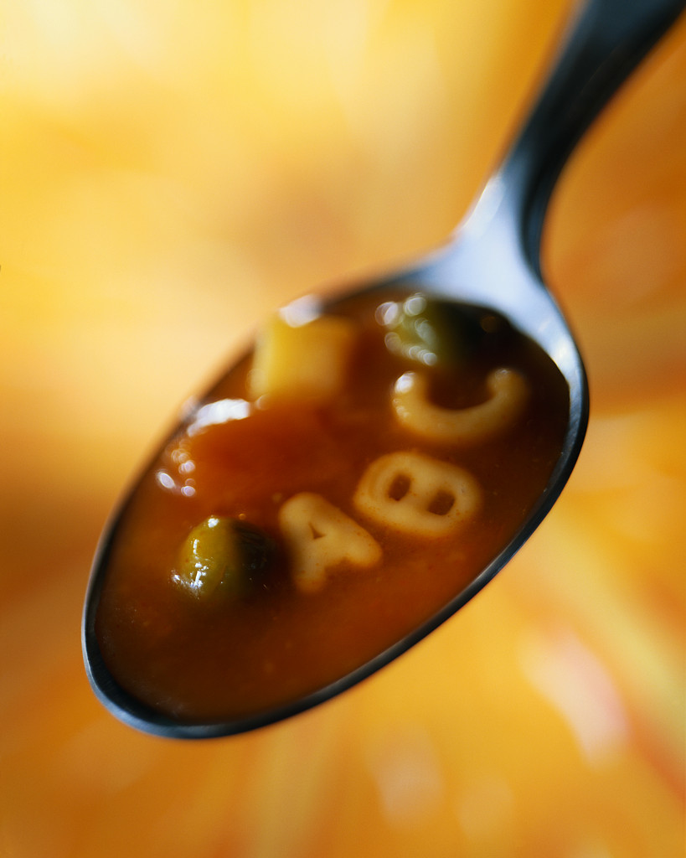 Do You Know What’s In Your Alphabet Soup?

BIP – Behavior Intervention Plan

BSP - Behavior Support Plan

CBA – Curriculum Based Assessment

CBM – Curriculum Based Measure

DPR – Daily Progress Report

FBA – Functional Behavioral Assessment

ICT – Instructional-Consultative Team Model

IEP – Individualized Educational Plan

IST – Instructional Support Team

ODRs – Office Discipline Referrals

PBS – Positive Behavior Support

PCP – Person Centered Planning

PLC – Professional Learning Communities

RtI – Response to Intervention

SCS – School Climate Survey

SET-D – School-wide Evaluation Tool-Delaware

SWPBS – School-wide Positive Behavior Support

