Delaware School Climate Surveys Interpretation Worksheet
School Climate, Bullying, Engagement

HOME Version

Report Interpretation Key
Table Code by Scale |  | Table Code by Score Type
School Climate Scale – Table 1 |  | Standard Scores – Table a |  | Bold – Total Scores
Bullying Scale – Table 3 |  | Average Scores – Table b |  | Green – Favorable
Engagement Scale – Table 4 |  | Percentage Response Scores – Table c |  | Red – Unfavorable

 | Favorable (GREEN) |  | Unfavorable (RED)
Scale | Standard Score | Average Score | Standard Score | Average Score
School Climate & Engagement Scales | 110 and above | 3.4 and above | 89 and below | 2.5 and below
Bullying Scale | N/A | N/A | 110 and above | 3.0 and above

Standard Score Distribution Average Item Score Calculation
Determine: Do your respondents’ scores reflect positive or negative perceptions of school climate, regardless of how your school compares to other schools?

Determine: How does your school compare to other like schools?

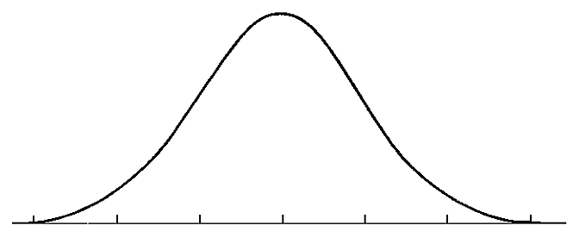
SS = 110
SS = 89
Considerable Sizeable
Concerns Strengths

Average scores are calculated by finding the average of all responses for each item.

Example:
Responses to Item 5 = 2,3,3,3,4,2
2+3+3+3+4+2= 17
17/6= 2.82
Average Item Score = 2.83

HOME DATA REPORT
School Climate Scale – Table 1

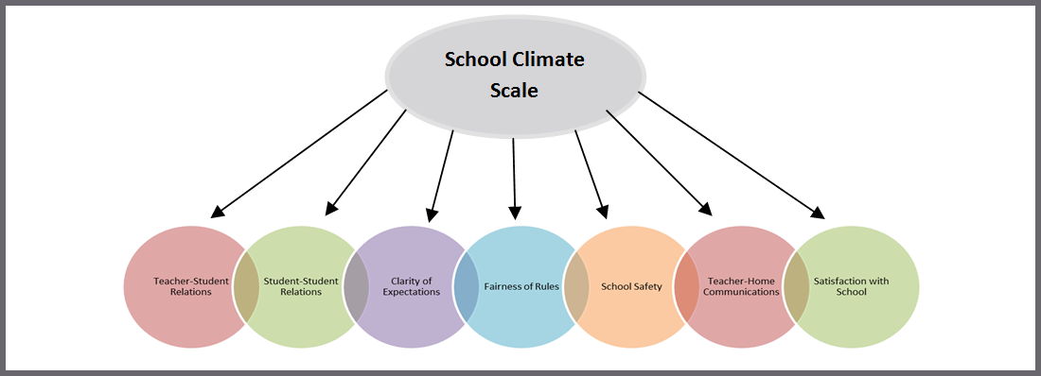

Response Scale: 1=Disagree A Lot 2=Disagree 3=Agree 4=Agree A Lot

AVERAGE ITEM SCORE (AIS): TRENDS REVIEW

Table | Use to… | Ask yourself…
1b  School Climate  Average Item Scores | Note the sizable strengths and considerable concerns for YOUR school. A score of 3 or above means that the respondents on average agree or agree a lot. Remember, lower scores are preferred for Bullying School-wide. | What areas are strengths for our school? What areas do we need to address? Are there differences within or between race groups? Do families view peer relationships positively? Do families feel rules are clear and fair?

School Climate Scale Totals (AIS)
Our Strengths |  | Concerns to Address
Additional Notes
 | School Climate Scale by Race (AIS)
 | Our Strengths | Concerns to Address
 | Additional Notes

PERCENT RESPONSE SCORE: TRENDS REVIEW
Table | Use to… | Ask yourself…
1c  School Climate  Percentage Response Scores | Note individual items that caused scores to be low or high. By looking at this data, you can find out which items families feel strongly about and direct efforts accordingly. | Were there any individual items from a subscale that had a particularly high or low response percentage? How did this impact our overall score? What can we do to address these focus areas?

Subscales | Our Strengths  (Item Numbers) | Concerns to Address  (Item Numbers)
Teacher-Student Relations
Student-Student Relations
Clarity of Expectations
Fairness of Rules
School Safety
Teacher-Home Communications
Satisfaction with School
Additional Notes

STANDARD SCORE (SS): TRENDS REVIEW
Table | Use to… | Ask yourself…
1a  School Climate  Standard Scores | Compare your school to other schools serving the same grade level (e.g. ES, MS, HS). A score of 100 is average, so in general, scores above 100 illustrate your school has higher scores than other same level schools. | What are our strengths and weaknesses compared to other schools that serve similar age students? Are there differences between and within race groups that we need to explore?

School Climate Scale Totals (SS)
Our Strengths | Concerns to Address
Additional Notes

School Climate by Race (SS)
Our Strengths | Concerns to Address
Additional Notes

GRAPH: TRENDS REVIEW
Graph | Use to… | Ask yourself…
1b  School Climate  Average Score  Cross-Year Review | Note school’s average item scores per subscale for this school year and 2 previous years (if data are available). | By subscale and overall, have our average item scores per subscale increased, decreased, or maintained over the years?

Our Increased Areas | Our Decreased Areas | Our Maintained Areas
Additional Notes

HOME DATA REPORT
Bullying Scale* – Table 3
*A high score on this subscale is negative because items are negatively worded

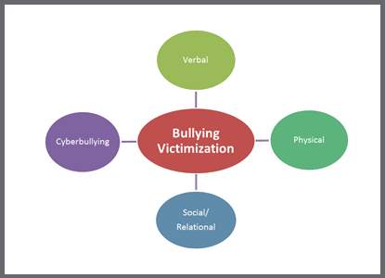

Response Scale: 1= Never 2=Less than once a month 3=Once or twice a month
4=Once a week 5= Several times a week 6= Every day

AVERAGE ITEM SCORE (AIS): TRENDS REVIEW

Table | Use to… | Ask yourself…
3b  Bullying  Average Item Scores | Note the sizable strengths and considerable concerns for YOUR school. Explore families’ perceptions of the frequency of what types of bullying occur in the school. Keep in mind, lower scores are better. | What areas are strengths for our school? What areas do we need to address? Are there differences to explore within and between races? Are there differences in what types of bullying families perceive as a problem in your school? Do families see physical bullying as occurring more often than verbal?

Bullying Scale Totals (AIS)
Our Strengths | Concerns to Address
Additional Notes

Bullying by Race (AIS)
Our Strengths | Concerns to Address
Additional Notes

PERCENT RESPONSE SCORE: TRENDS REVIEW

Table | Use to… | Ask yourself…
3c  Bullying  Percentage Response Scores | Review families’ responses to the individual questions. Note individual items that caused subscale scores to be low or high. By looking at this data, you can identify items families note as occurring more or less frequently. | Were there any individual items from a subscale that had particularly high or low response percentage? How did this impact our overall score? What can we do to address these focus areas?

Subscales | Our Strengths  (Item Numbers) | Concerns to Address  (Item Numbers)
Verbal Bullying
Physical Bullying
Social/Relational Bullying
Additional Notes

STANDARD SCORE (SS): TRENDS REVIEW

Table | Use to… | Ask yourself…
3a  Bullying  Standard Scores | Compare your school to other schools serving the same grade level (e.g., ES, MS, HS). A score of 100 is average, so in general, scores above 100 illustrate your school has higher scores than other same level schools. Use these scores to determine what kinds of bullying families identify as a problem in relation to similar schools. Remember that low scores are preferred. | What are our strengths and weaknesses compared to other schools that serve similar age students? Are there differences between and within race groups that we need to explore? Are some standard scores higher? Why?

Bullying Scale Totals (SS)
Our Strengths | Concerns to Address
Additional Notes

Bullying by Race (SS)
Our Strengths | Concerns to Address
Additional Notes

GRAPH: TRENDS REVIEW

Graph | Use to… | Ask yourself…
3b  Bullying  Average Scores Cross-Year Review | Note school’s average item scores per subscale for this school year and 2 previous years (if data are available). | By subscale and overall, have our average item scores per subscale increased, decreased, or maintained over the years?

Our Increased Areas | Our Decreased Areas | Our Maintained Areas
Additional Notes

HOME DATA REPORT
Engagement Scale – Table 4

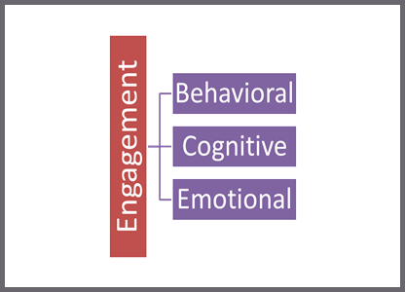

Response Scale: 1=Disagree A Lot 2=Disagree 3=Agree 4=Agree A Lot

AVERAGE ITEM SCORE (AIS): TRENDS REVIEW

Table | Use to… | Ask yourself…
4b  Engagement  Average Item Scores | Note the sizable strengths and considerable concerns for YOUR school. A score of 3 or above means that the respondents on average agree or agree a lot. | What areas are strengths for our school? What areas do we need to address? Are there differences within or between race groups? Do our families report more cognitive, behavioral, or emotional engagement?

Engagement Scale Totals (AIS)
Our Strengths | Concerns to Address
Additional Notes

Engagement by Race (AIS)
Our Strengths | Concerns to Address
Additional Notes

PERCENT RESPONSE SCORE: TRENDS REVIEW

Table | Use to… | Ask yourself…
4c  Engagement  Percentage Response Scores | Note individual items that caused subscale scores to be low or high. By looking at this data, you can find out which items families feel strongly about and direct efforts accordingly. | Were there any individual items from a subscale that had particularly high or low response percentage? How did this impact our overall score? What can we do to address these focus areas?

Subscales | Our Strengths  (Item Numbers) | Concerns to Address  (Item Numbers)
Cognitive Engagement
Behavioral Engagement
Emotional Engagement
Additional Notes

STANDARD SCORE (SS): TRENDS REVIEW
Table | Use to… | Ask yourself…
4a  Engagement Standard Scores | Compare your school to other schools serving the same grade level (e.g. ES, MS, HS). A score of 100 is average, so in general, scores above 100 illustrate your school has higher scores than other same level schools. | What are our strengths and weaknesses compared to other schools that serve similar age students? Are there differences between and within races that we need to explore?

Engagement Scale Totals (SS)
Our Strengths | Concerns to Address
Additional Notes

Engagement by Race (SS)
Our Strengths | Concerns to Address
Additional Notes
GRAPH: TRENDS REVIEW
Graph | Use to… | Ask yourself…
4b  Engagement  Average Scores Cross-Year Review | Note your school’s average item scores per subscale from this school year and the previous 2 years (if data are available). | By subscale and overall, have our average item scores per subscale increased, decreased, or maintained over the years?

Our Increased Areas | Our Decreased Areas | Our Maintained Areas
Additional Notes

