Educator Considerations
– Restorative Practices Challenge and Try to Change Existing Discipline Methods
Restorative Practices Fall in the “WITH” Discipline Styles of Educators:

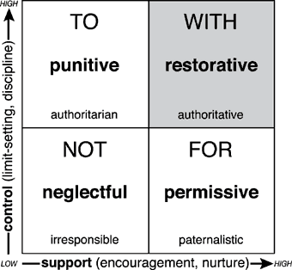

(Costello,B., Wachtel, J. & Wachtel, T. (2009). The Restorative Practices Handbook
for Teachers, Disciplinarians and Administrators.)

Restorative Practices Are Complimentary to PBIS:
Restorative Practice Methods Should be:
- respectful

- fair

-restorative
Teacher Practices Should:
- develop empathy

- enhance responsibility and accountability

-promote positive behavioral change

Source: www.como.wa.edu.au & Douglas, D., St. Rose, D., & Lieberman, K. (2011). Integrating restorative practices Into a positive behavior support framework. Presentation at 2011 International PBIS Conference.

Student Considerations
– Restorative Practices Change How Students Discuss and Address Negative Behavior
To Encourage Objective Student Reflection of Negative Behavior:
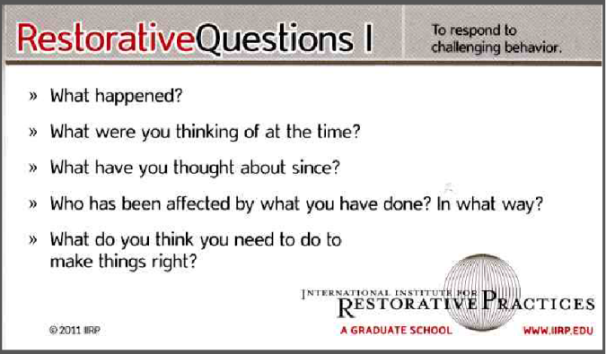

To Confront the Consequences of Negative Behavior:
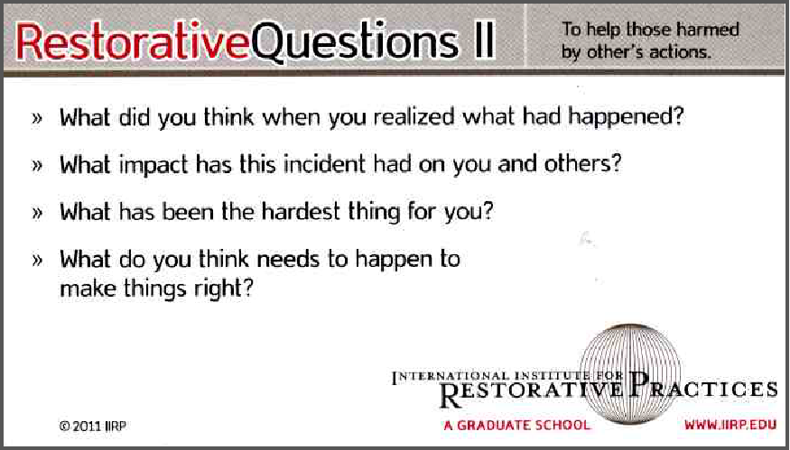

Source: International Institute for Restorative Practices (http://www.iirp.edu/ )

Parental Considerations
– Restorative Practices Change Parent-Teacher Conversations and Parent Responses
Use An “Atypical” Sample Script:

“Mrs Smith, I am ringing about an incident involving Paul. He has admitted to stealing an iPod from another student. You may be aware that at our school we deal with anything that goes wrong in Restorative ways. This means we focus on three things. What happened? Who has been harmed or hurt? And, what is needed to make things right? In talking with Paul he now understands the hurt he has caused and also mentioned that you will be very disappointed. The good news is that he is keen to make things right and wants you to be part of this happening. Paul is not a bad student. It is his behaviour we are concerned about. This is an opportunity for learning, one that Paul will look back on and feel good about, because he took responsibility by making things right with everyone.

To Avoid “Typical” Parental Shame Responses :

- “I have to get out of the house, away from everybody!” [WITHDRAWAL]
- “When I come back I have to eat chocolate to feel okay!” [AVOIDANCE]
- “Then I think, the bloody school is always picking on my kid!” [ATTACK OTHERS]
- “By the time I have arrived at the school, I feel like I’m a really bad parent!” [ATTACK SELF]

Source: www.como.wa.edu.au

