Name ___________________________ Date _________________

Behavior Reflection Sheet

This is a picture of why I had to move my clip to red (OH NO!).

The bad choice I made was:
 | I was not Acting Safely with my friends. |  | I was not Acting safely with my body.
 | I chose not to Be a friend to my classmates. |  | I chose not to Be a friend to my teacher.
 | I was not Choosing manners when the teacher was teaching. |  | I did not make good choices at lunch.
 | I did not make good choices at specials(art, gym, guidance) |  | I did not make good choices at recess.
Please see the other side for more information about your child’s day.

This is how I feel:
  happy | 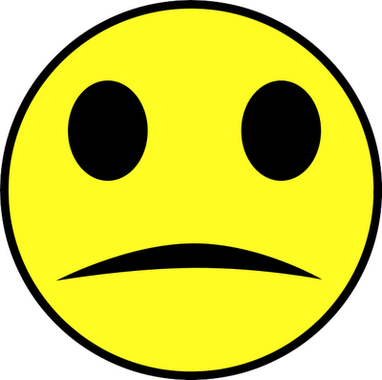  so-so |   sad

This is what I can do to make a good choice:
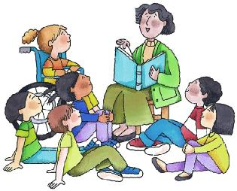  Listen carefully | 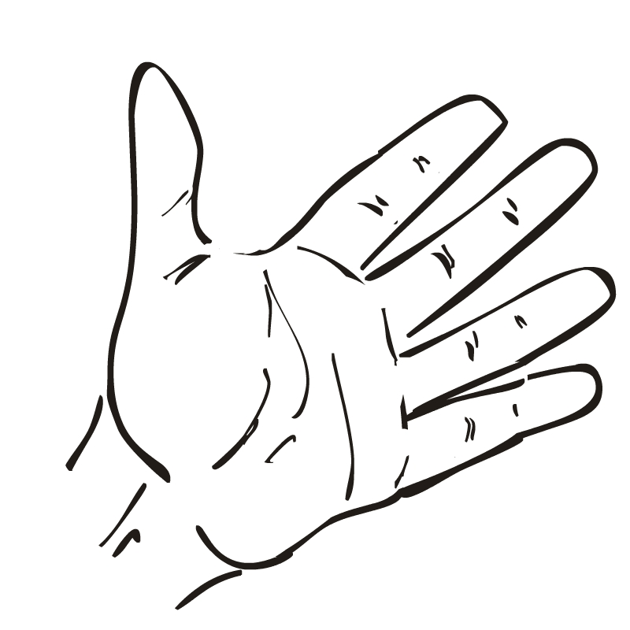  keep hands to myself | 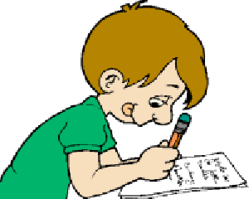  follow directions

A note from the teacher:
_______________________________________________________________
_ _ _ _ _ _ _ _ _ _ _ _ _ _ _ _ _ _ _ _ _ _ _ _ _ _ _ _ _ _ _ _ _ _ _ _ _ _ _ _ _ _
_______________________________________________________________
_______________________________________________________________
_ _ _ _ _ _ _ _ _ _ _ _ _ _ _ _ _ _ _ _ _ _ _ _ _ _ _ _ _ _ _ _ _ _ _ _ _ _ _ _ _ _ _
_______________________________________________________________

A note from home:
_______________________________________________________________
_ _ _ _ _ _ _ _ _ _ _ _ _ _ _ _ _ _ _ _ _ _ _ _ _ _ _ _ _ _ _ _ _ _ _ _ _ _ _ _ _ _
_______________________________________________________________
_______________________________________________________________
_ _ _ _ _ _ _ _ _ _ _ _ _ _ _ _ _ _ _ _ _ _ _ _ _ _ _ _ _ _ _ _ _ _ _ _ _ _ _ _ _ _ _
_______________________________________________________________

This is your child’s ______ reflection sheet. If your child needs to complete 5 reflection sheets it will result in a school discipline write up.
Please sign and have your child return this form the next school day.
Parent Signature:

X______________________________________________

