Preschool Behavior Reflection Sheet
The reflection sheet on the following two pages can be used to help pre-k students reflect on their behavior and feelings.

In the top box, the child can draw a picture of what occurred. The teacher can help the child complete the rest of the sheet by reading the prompts and answer choices. The reflection sheet should be discussed with the child after completing it.

The teacher can write a note and it can be sent home to the child’s family.

Name ___________________________ Date _________________

Behavior Reflection Sheet

This is a picture of why I had to move my clip to red (OH NO!).

The bad choice I made was:
 | I was not Acting Safely with my friends. |  | I was not Acting safely with my body.
 | I chose not to Be a friend to my classmates. |  | I chose not to Be a friend to my teacher.
 | I was not Choosing manners when the teacher was teaching. |  | I did not make good choices at lunch.
 | I did not make good choices at specials(art, gym, guidance) |  | I did not make good choices at recess.
Please see the other side for more information about your child’s day.

This is how I feel:
  happy |   so-so |   sad

This is what I can do to make a good choice:
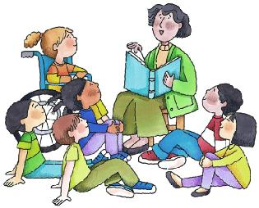  Listen carefully | 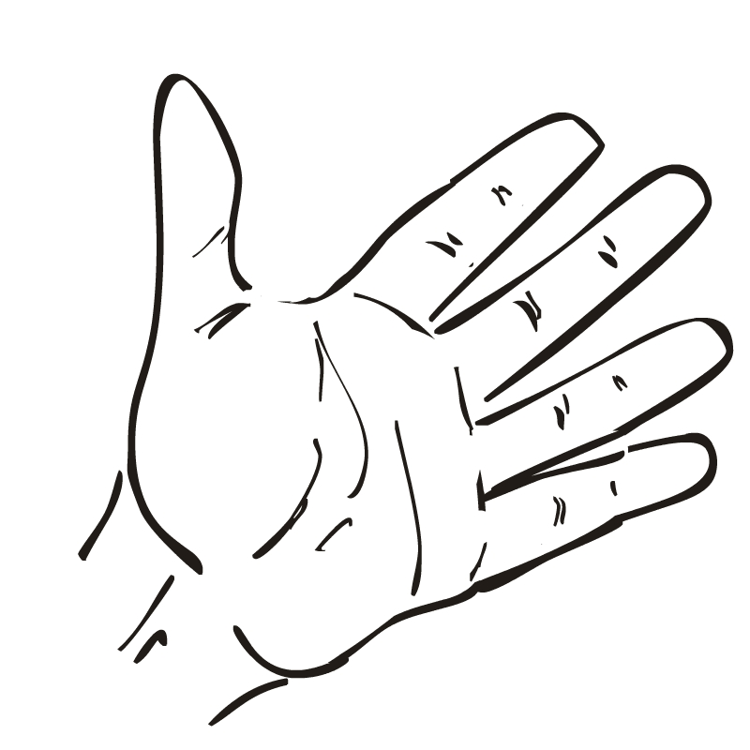  keep hands to myself |   follow directions

A note from the teacher:
_______________________________________________________________
_ _ _ _ _ _ _ _ _ _ _ _ _ _ _ _ _ _ _ _ _ _ _ _ _ _ _ _ _ _ _ _ _ _ _ _ _ _ _ _ _ _
_______________________________________________________________
_______________________________________________________________
_ _ _ _ _ _ _ _ _ _ _ _ _ _ _ _ _ _ _ _ _ _ _ _ _ _ _ _ _ _ _ _ _ _ _ _ _ _ _ _ _ _ _
_______________________________________________________________

A note from home:
_______________________________________________________________
_ _ _ _ _ _ _ _ _ _ _ _ _ _ _ _ _ _ _ _ _ _ _ _ _ _ _ _ _ _ _ _ _ _ _ _ _ _ _ _ _ _
_______________________________________________________________
_______________________________________________________________
_ _ _ _ _ _ _ _ _ _ _ _ _ _ _ _ _ _ _ _ _ _ _ _ _ _ _ _ _ _ _ _ _ _ _ _ _ _ _ _ _ _ _
_______________________________________________________________

This is your child’s ______ reflection sheet. If your child needs to complete 5 reflection sheets it will result in a school discipline write up.
Please sign and have your child return this form the next school day.
Parent Signature:

X______________________________________________

