SWPBIS-SEL Integration Plan
Adapted from Bradshaw et al. (2014) by Sara Whitcomb
1. Develop a Statement of Purpose. Consider what efforts your building is planning on integrating, why this is important, and what is the vision or ultimate outcome you are trying to achieve. Consider setting a concrete, measureable goal (e.g. decreases in disciplinary incidents, decreases in nurse visits, decreased individual contacts with school counselor)

2. Sample Integrated Materials
*Develop a crosswalk to share with implementers to ensure they are bridging language between efforts.
SEL Curriculum Lessons (e.g. Second Step) | SWPBIS Core Values/Behavioral Expectations
 | Be Respectful | Be Responsible | Be Safe
Learning to Listen | X | X
Focusing Attention | X | X
Following Directions | X | X | X

Guiding Questions for Team
- What will your crosswalk look like? What core values have you/will you establish and what SEL skills are you teaching students?
- What do you currently have for visuals in non-classroom and classroom areas that reflect your school-wide core values/behavioral expectations/SEL skill reminders/responses to challenging behaviors? Do you need more visuals across the building? Do visuals include consistent language so that students are getting similar messages in all locations?
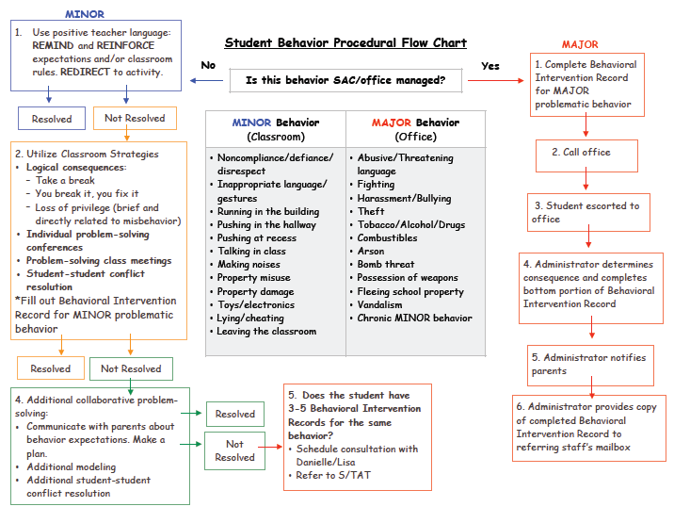
- Develop Plan for Job-Embedded Professional Development
Consider:
- How will your team develop and/or use current structures through which teachers can learn from one another and you about your integrated SEL/SWPBIS effort?
  - Consider dedicated time at faculty meetings for SEL/SWPBIS updates and data sharing
  - Consider dedicated time during teacher grade level common planning time to reflect on student data and engage in classroom problem-solving.
  - Consider dedicated time during which teachers can engage in peer observations of SEL/PBIS instruction
  - Consider developing a plan for orienting and providing support related to SEL/SWPBIS to early career teachers in your building
- How will you obtain and maintain teacher buy-in related to your integrated SEL/SWPBIS effort?
  - Consider mechanisms through which teachers can give feedback and input
  - Consider surveys that will enable teachers to identify school climate needs

- Create a plan for collecting, managing and using fidelity and outcome data
- What implementation measures make the most sense for your school (e.g. measures on www.pbisapps.org such as the Tiered Fidelity Inventory, Delaware Self-Discipline Rubric
- How often will you complete implementation measures?
- How will your team use these data? How will you share these data with teachers/staff?
- What outcomes are you most interested in? What data source will work best to measure intended outcomes (e.g. office disciplinary referrals, nurse visits, schoolwide screening)
- How will you collect these data?
- How often will your team look at these data? How will they make Tier 1 decisions based on the data?

- Implementation Timeline
- Create a timeline that will guide your team and teachers of key monthly tasks related to teaching, collecting data, using data to inform instructional changes

Month | Key Activities | Who Is Responsible?

