Instructions for the Yellow Pages Activity

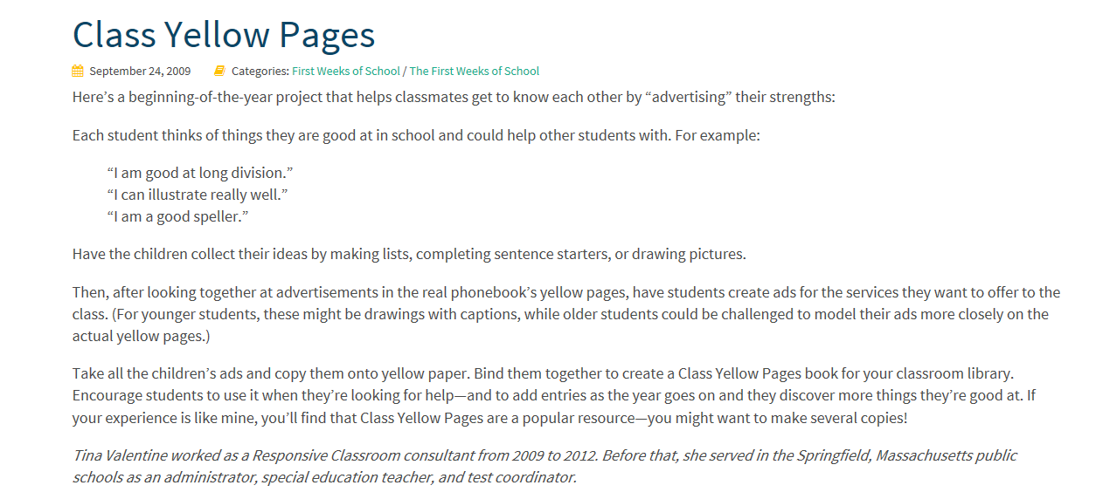

From the Responsive Classroom Website: (https://www.responsiveclassroom.org/blog/class-yellow-pages)

