The School-wide PBIS Tiered Fidelity Inventory 2.10
- Once you have your Action Plan/handwritten TFI, etc., go to https://www.pbisapps.org/
  - Firefox seems to support this website better than Internet Explorer
- In the top right corner, you will see PBIS Applications Login- click on it
  - Enter your username and password
  - Click “Login”
- On the left side of the top bar, you will see PBIS Assessment. Click on it. It will take you to a page that has “Open Survey Windows” and “Closed Survey Windows.”
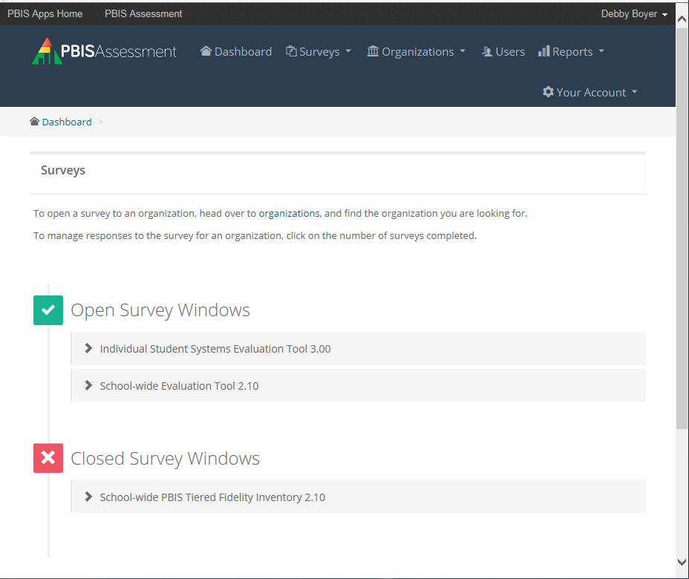
- You are looking for the tool called “School-wide PBIS Tiered Fidelity Inventory 2.10.” Before you can input the scores for a specific school, you have to make sure that school’s TFI is in the “Open Survey Windows” section.
  - How to open a survey window:
    - Click on the sideways caret (>) to see the schools with closed survey windows. You will see a list of schools with a blank check box to the left of their school name. Click the box of the school or schools whose surveys you wish to open. Once you have clicked your chosen boxes, click on the dark blue/black box that says “Change Dates for __ Selected Surveys”
      - The ___ part will change depending on how many schools you have selected (e.g., if you clicked the checkboxes for Carrcroft and Brick Mill, that box will say “Change Dates for 2 Selected Surveys”).
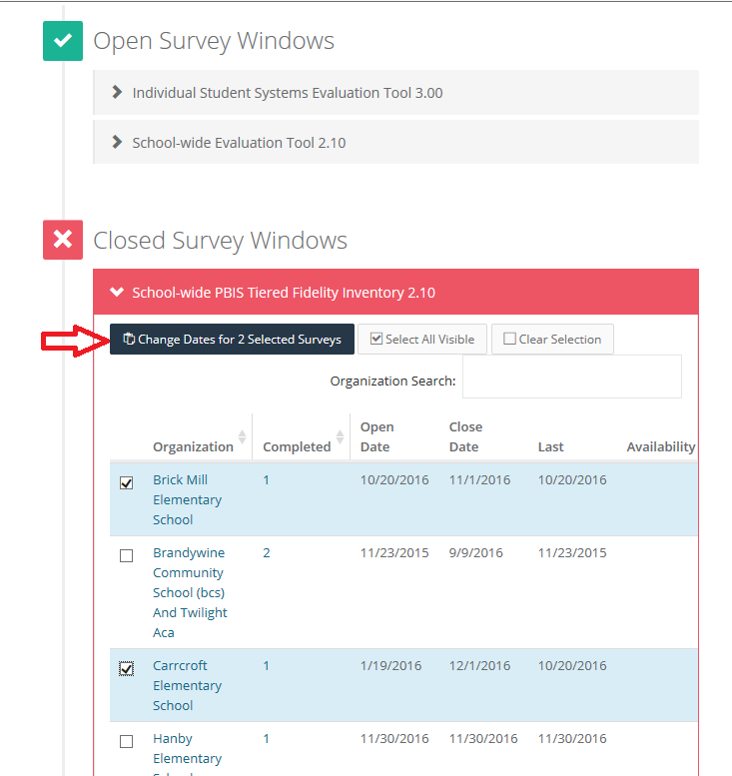
  - When you click the “Change Dates” button, a date range will pop up giving you an “Open Date” and a “Close Date.” The “Close Date” is really the only one that matters in this instance. It doesn’t matter what you make the Close Date as long as it’s on or after the day that you are inputting the information. For example, if you want to enter in a TFI for a school on December 12th, the Close Date just needs to be December 12th or later. You can open or close a survey at any time.
  - But wait—what if I don’t see the school I’m looking for under the Open or Closed survey sections of the School-wide PBIS Tiered Fidelity Inventory 2.10?
    - Contact Laura Davidson (LDavids@UDel.edu) or Debby Boyer (DBoyer@UDel.edu) and ask if they can open the TFI for your school.
- Now it’s time to actually input the survey information! If you opened the survey for your school, you’ll find it under Open Survey Windows.
- If the school has previously completed the TFI, the number of times they completed it will appear under “Completed.”
- To input new scores for that school, look on the right-hand side and click “Take Survey” (under “Availability”).
- You will arrive at the first screen. Click or type in the day the TFI was completed.
- Under “Members completing the Inventory at this time,” indicate whether the TFI was completed by the school’s team with an external coach, the team without an external coach, or the external coach without the team.
- Under “Individual(s) completing the TFI Walkthrough Tool,” select “TFI Walkthrough tool not completed.”
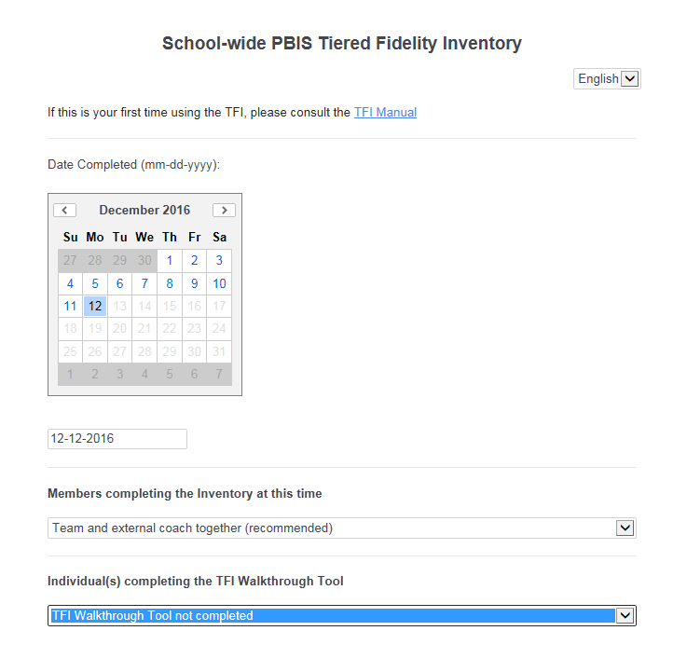
- Click the green sideways carets at the bottom of the screen to continue.
- You will arrive at a page with the actual TFI Items. SCROLL DOWN to the Tier II: Targeted SWPBIS Features section if you only have Tier 2 data.
  - Select the answers that the school indicated for each item (e.g., 0= Not Implemented, 1= Partially Implemented, 2= Fully Implemented).
- Click the green sideways carets at the bottom of the screen to continue.
- Ignore the next page. These questions are optional. Click Submit Survey.
- Once you submit, click “Dashboard” to go back to your open and closed survey page.
- Give the program about a minute to process the data you just entered. Once that data is processed, you should notice that the number under “Completed” increased by one.
Creating and Saving Data for Schools
- Now that you’ve submitted your new TFI, click on “View Reports” on the far right side.
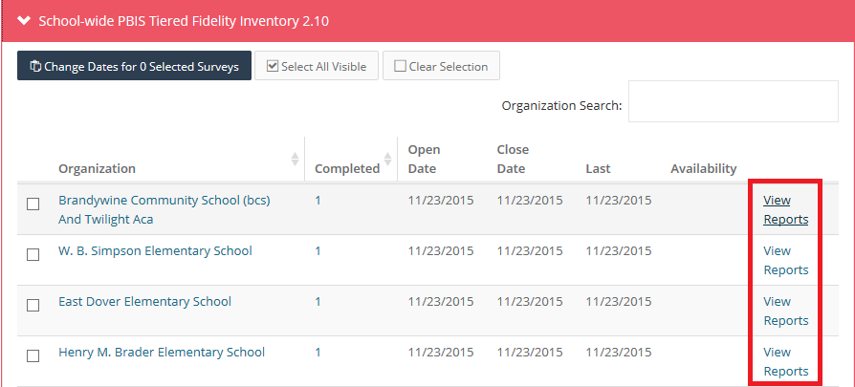
- A new page will pop up. On the left side of the screen, you will see “Select Report.” It automatically selects “Total.” Click on this and change it to “Subscale”
  - Click “Generate”
  - Under “Generate,” click PDF. Open the PDF in the pop up.
  - Save this Subscale PDF.
  - Now go back to “Select Report” and choose “Items.”
  - “Generate”
  - Below “Generate,” click PDF. Open the PDF in the pop up.
  - Save this Item Scores PDF.
- You should now have an item report and subscale report for your school/organization.

