[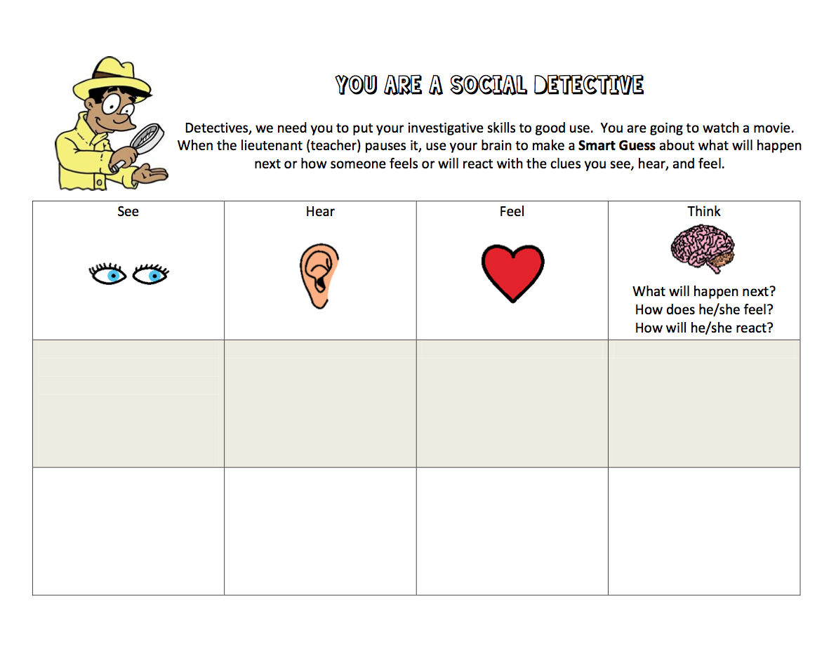](https://drive.google.com/file/d/0B1jXwQR3tC3pWndiV0RPMmpUS28/edit?usp=sharing)