2020-2021 DSCS Report Download Directions

The following instructions will assist Delaware School Climate Coordinators and District Personnel in downloading Student, Teacher, and Home ONLINE reports from the CoVitality App.

INSTRUCTIONS FOR SCHOOL LEVEL DOWNLOADS

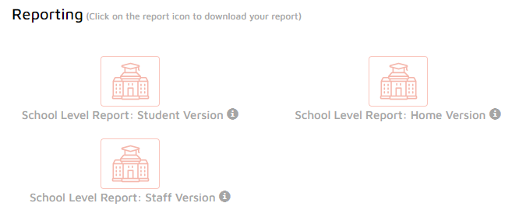
- Log-in to the CoVitality app: https://deschoolclimate.mosaic-network.com/login
- Once logged in, on the right of the school dashboard, there is a section titled “Reporting”
- In this section, you will see each of your reports that can be downloaded based on the populations that completed the reports.
  - Student Version
  - Home Version
  - Staff Version
- To download/view report, click on the house icon for the version you want do download (i.e., Staff Version)
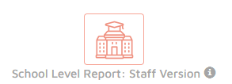

INSTRUCTIONS FOR DISTRICT LEVEL DOWNLOADS

The following instructions are for district personnel involved in the DSCS process only. If you are a Delaware School Climate Coordinator, please disregard these instructions.

- Log-in to the CoVitality app: https://deschoolclimate.mosaic-network.com/login
- The top bar on your dashboard should display dropdown menus for the district, school, survey version, and administrative period.
- To download a district-wide report:
  - Click on the district that you are affiliated with (ex: Red Clay)
  - On the right of the district dashboard, there is a section titled “Reporting”
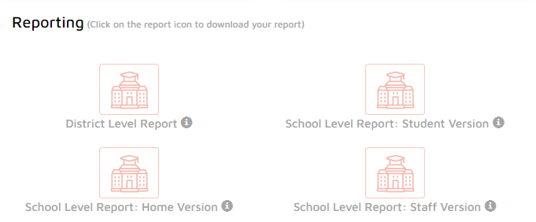
  - In this section, you will see each of your reports that can be downloaded at the school level based on the populations that completed the survey.
    - Student Version
    - Home Version
    - Staff Version
- To download/view the District report, click on the house icon for the District Level Report. This will download a report that includes data from each version for all of your participating schools. To download data from individual schools, see the step below.
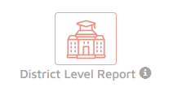
- To download a school level report:
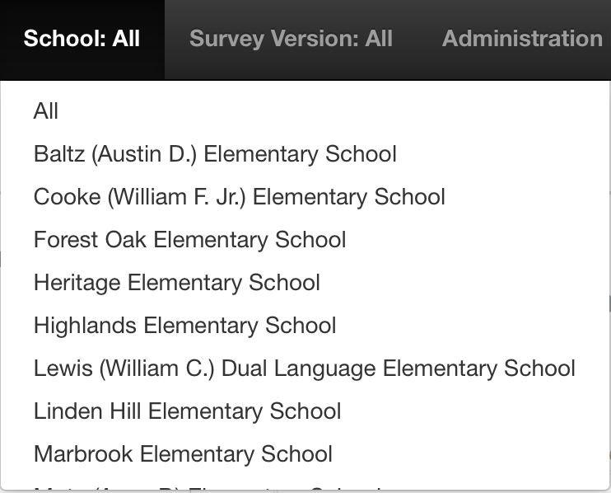
  - Go to the top black bar and select the school within your district that you would like to view a report for.
  - Click the red house icon for the version you want to download (i.e., Staff Version)
