CICO-SWIS
Point Card Examples
CICO-SWIS Point Card Requirements:
- Standard for all students enrolled
- Three point Scale (e.g., 0, 1, 2)
- 3-5 School-wide Expectations
- Up to 10 Check in times
Template
- General Template (Vertical)
- General Template (Horizontal)
- Early Childhood Example
- Elementary Examples
- Middle School Examples
- High School Examples

General Template (Vertical):

Name: |  |  | Points Goal:
Date: |  |  | Points Earned:
Check-In Adult: |  |  | Goal Met?
Expectation | Class 1 | Class 2 | Class 3 | Class 4
[Add]
[Add]
[Add]
[Add]
[Add]
Signature/Helpful Comments
Parent Signature/ Comments

General Template (Horizontal):

Name: |  |  | Points Goal:
Date: |  |  | Points Earned:
CICO Adult: |  |  | Goal Met?
Schoolwide Expectations | Class 1 | Class 2 | Class 3 | Class 4 | Class 5 | Class 6 | Class 7 | Signature/ Helpful Comments
[Add]
[Add]
[Add]
[Add]
[Add]
Parent Signature/ Comments

Early Childhood Example:
Screenshot:
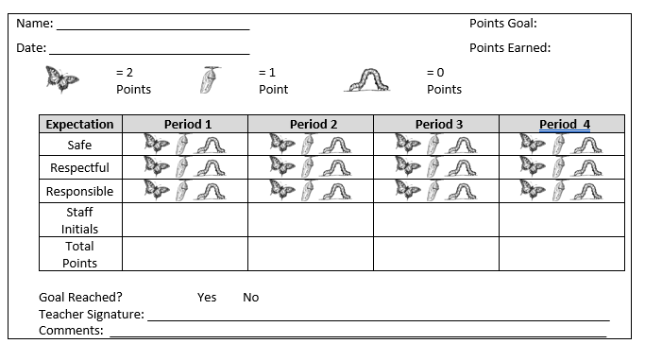

Elementary School Examples:

HAWK Report – Helping A Winning Kid

Name: Points received
Date:
Daily Goal _____ Daily goal reached? Yes No

GOALS | Period 1  8:30-10 | Period 2  Recess | Period 3  10:15-11:30 | Period 4  Lunch | Period 5  12:15-1:15 | Period 6  1:15-3:00
Be Safe | 0 1 2 | 0 1 2 | 0 1 2 | 0 1 2 | 0 1 2 | 0 1 2
Be Respectful | 0 1 2 | 0 1 2 | 0 1 2 | 0 1 2 | 0 1 2 | 0 1 2
Be Responsible | 0 1 2 | 0 1 2 | 0 1 2 | 0 1 2 | 0 1 2 | 0 1 2
TOTAL
Comment(s)
Signature

H.U.G.
(Hello, Update, Goodbye)

Name: __________________________________ Date: _______________________

Please indicate whether the student has met the goal during the time period indicated.
Meets: ☺ (2 points) So, so: 😐 (1 point) Doesn’t meet: ☹ (0 points)
Goals | AM to Lunch | Lunch Recess | PM
Be Safe | ☺ 😐 ☹ | ☺ 😐 ☹ | ☺ 😐 ☹
Be Kind | ☺ 😐 ☹ | ☺ 😐 ☹ | ☺ 😐 ☹
Be Responsible | ☺ 😐 ☹ | ☺ 😐 ☹ | ☺ 😐 ☹
Total Points
Teacher Initials

HUG Daily Goal _____/18 HUG Daily Score _____/18
Teacher Comments: Please state briefly any specific behaviors or achievements that demonstrate the student’s progress.

Parent’s Signature and Comments:

School Name
Check In Check Out (or other name of program i.e. “PAWS”)
Student name:____________________________ CICO mentor:________________________ Date:________________

 | Expectation #1 | Expectation #2 | Expectation #3 | Total Points | Teacher Initials
Period 1 | 0 1 2 | 0 1 2 | 0 1 2
Period 2 | 0 1 2 | 0 1 2 | 0 1 2
Period 3 | 0 1 2 | 0 1 2 | 0 1 2
Period 4 | 0 1 2 | 0 1 2 | 0 1 2
Period 5 | 0 1 2 | 0 1 2 | 0 1 2
Period 6 | 0 1 2 | 0 1 2 | 0 1 2
Period 7 | 0 1 2 | 0 1 2 | 0 1 2
Period 8 | 0 1 2 | 0 1 2 | 0 1 2
Key:
2 points | Behavior was appropriate; student managed his/her own behavior.
1 point | Behavior was somewhat appropriate; student needed one reminder.
0 points | Behavior was inappropriate; student continued problem behavior after reminder(s).

Middle School Examples:

Daily Progress Report

Name _____________________ Rating Scale Points Possible _______
Date______________ _________ 2=Great Goal to meet_______
1=Sorta Points received_____
0=Try Again Goal Met Yes No

Goal | Period 1 | Period 2 | Period 3 | Period 4 | Period 5 | Period 6 | Period 7
Be Safe | 0 1 2 | 0 1 2 | 0 1 2 | 0 1 2 | 0 1 2 | 0 1 2 | 0 1 2
Be Responsible | 0 1 2 | 0 1 2 | 0 1 2 | 0 1 2 | 0 1 2 | 0 1 2 | 0 1 2
Be Respectful | 0 1 2 | 0 1 2 | 0 1 2 | 0 1 2 | 0 1 2 | 0 1 2 | 0 1 2
TOTAL

Comments

Parent/Guardian Signature

Secondary School Example

Name: Points received
Date:
Daily Goal _____ Daily goal reached? Yes No

Goal/  Period | Be Responsible | Be Respectful | Do Your Personal Best | Signature/ Comment(s):
Period 1: | 0 1 2 | 0 1 2 | 0 1 2
Period 2: | 0 1 2 | 0 1 2 | 0 1 2
Period 3: | 0 1 2 | 0 1 2 | 0 1 2
Period 4: | 0 1 2 | 0 1 2 | 0 1 2
Period 5: | 0 1 2 | 0 1 2 | 0 1 2
Period 6: | 0 1 2 | 0 1 2 | 0 1 2

Parent/Guardian Signature

High School Examples:
Oregon High School
Name _____________________________________ Points: _____________
CLASS | Perseverance | Respect | Integrity | Discipline | Excellence | Teacher initial
1st period  _________ | 0 1 2 | 0 1 2 | 0 1 2 | 0 1 2 | 0 1 2
2nd period  _________ | 0 1 2 | 0 1 2 | 0 1 2 | 0 1 2 | 0 1 2
3rd period  __________ | 0 1 2 | 0 1 2 | 0 1 2 | 0 1 2 | 0 1 2
4th period  _________ | 0 1 2 | 0 1 2 | 0 1 2 | 0 1 2 | 0 1 2

Parent / Guardian signature_______________________________
Comments? Questions? _____________________________________________________________________________________

California High School
Name _____________________________________ Points: _____________

Goals | 1/5 | 2/6 | 3/7 | 4/8 | Total  Points
Be Respectful | 0 1 2 | 0 1 2 | 0 1 2 | 0 1 2
Be Responsible | 0 1 2 | 0 1 2 | 0 1 2 | 0 1 2
Follow Directions | 0 1 2 | 0 1 2 | 0 1 2 | 0 1 2
Be There & Be Ready | 0 1 2 | 0 1 2 | 0 1 2 | 0 1 2

Comments: ____________________________________________________________________________________

Check-In/Check-Out Form - Daily Progress Report
Name: __LaVonne Walker______ Date: __10/15/15_________________
Teachers: Please indicate Yes (2), So-So (1), or No (0) regarding student’s achievement for the following goals today.
Daily Goal: % Daily Score: %
Goals | Period 1/5 | Period 2/6 | Period 3/7 | Period 4/8
Be There | 2 | 2 | 2 | 1
Be Ready | 1 | 1 | 1 | 2
Best Effort | 2 | 1 | 2 | 1
Homework Complete | 1 | 0 | 1 | 0

Teacher comments: Please state briefly any specific behaviors or achievements that demonstrate the student’s progress.

Period 1/5 Behavior is improving!
Period 2/6
Period 3/7 Thanks for your great focus today _____________
Period 4/8

