Delaware School Climate Survey Interpretation Worksheet
School Climate and Techniques
STAFF Version

General Review Guidance:
- When reviewing data, note the number of respondents and reflect on percentage of eligible participants. There may be fewer responses than expected due to data cleaning process. While pg. 4 of the report typically provides this information, some numbers may differ due to this year’s survey process.
- Overall, missing scores indicate there were 5 or fewer surveys available to score this item; therefore, the scores are not reported.
- Note: The "Staff" position reporting includes administrators/supervisors, instructional or pupil support professional staff (e.g., School counselor, school psychologist, school nurse, librarian, educational diagnostician, consulting special education teacher), and paraprofessionals.

Report Interpretation Key
Scales |  | Score Types |  | Color Codes
School Climate |  | Average Item |  | Bold – Total Scores
Techniques |  | Percentage Response |  | Green – Favorable
 |  | Standard |  | Red – Unfavorable

 | Favorable (GREEN) |  | Unfavorable (RED)
Scale | Standard Score | Average Item Score | Standard Score | Average Item Score
School Climate & Techniques | 110 and above | 3.2 and above | 89 and below | 2.5 and below
School Climate – Bullying SW | 89 and below | 2.0 and below | 110 and above | 3.0 and above
Techniques – Punitive Techniques | 89 and below | 2.0 and below | 110 and above | 3.0 and above

Standard Score Distribution Average Item Score Calculation
Determine: Do your respondents’ scores reflect positive or negative perceptions of school climate, regardless of how your school compares to other schools?

Determine: How does your school compare to other like schools?

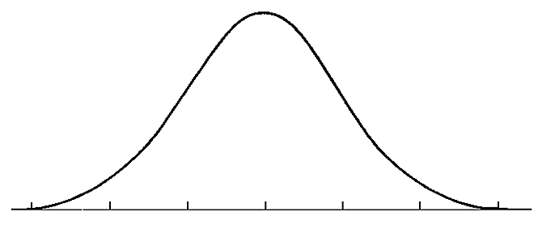
SS = 110
SS = 89

Average scores are calculated by finding the average of all responses for each item.

Example:
Responses to Item 5 = 2,3,3,3,4,2
2+3+3+3+4+2= 17
17/6= 2.83
Average Item Score = 2.83

Considerable Sizeable
Concerns Strengths
Determine: How does one know if differences in scores are significant? See pg. 4 of report
TEACHER/STAFF DATA REPORT
School Climate Scale

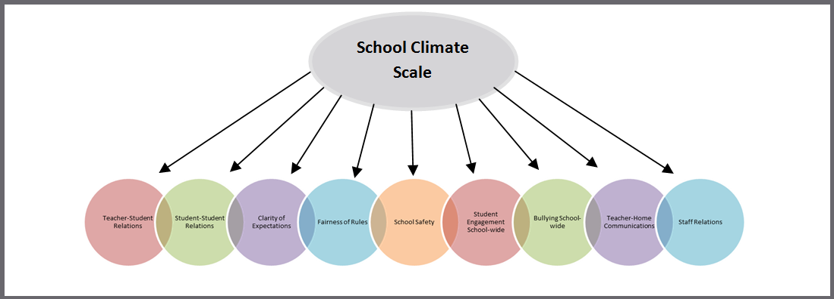

Response Scale: 1=Disagree A Lot 2=Disagree 3=Agree 4=Agree A Lot

Average Item Score Comparison – School Climate Scale BAR GRAPH (pg. 5)

Graph | Use to… | Ask yourself…
Average Item Score Comparison – School Climate Scale  (Cross Year-Review) | Note school’s average item scores per subscale for this school year and 2 previous years (if data are available). Note that the School Safety subscale was not included in the 2020-21 survey. | By subscale and overall, have our average item scores per subscale increased, decreased, or maintained over the years?

*Note: Current year data is represented in BLUE
Our Increased Areas | Our Decreased Areas | Our Maintained Areas
Additional Notes

Average Item Score – School Climate Scale TABLE (pg. 6)

Table | Use to… | Ask yourself…
School Climate  Average Item Scores for All Staff Positions Combined | Note the sizable strengths and considerable concerns for YOUR school. A score of 3 or above means that the respondents on average agree or agree a lot. Remember, lower scores are preferred for Bullying School-wide. | What areas are strengths for our school? What areas do we need to address? Are there differences within or between position groups? Do staff members view student relationships positively? Do staff members feel rules are clear and fair?

School Climate Average Item Score Totals
Our Strengths | Concerns to Address
Additional Notes

School Climate Scale by Position
Our Strengths | Concerns to Address
Additional Notes

School Climate Individual Item Responses (pg. 7-8)
Table | Use to… | Ask yourself…
School Climate  Individual Item Responses  (Percentage Response Scores) | Note individual items that caused scores to be low or high. By looking at this data, you can find out which items staff members feel strongly about and direct efforts accordingly. | Were there any individual items from a subscale that had particularly high or low response percentage? How did this impact our overall score? What can we do to address these focus areas?

Subscales | Our Strengths | Concerns to Address
Teacher-Student Relations
Student-Student Relations
Student Engagement School-wide
Clarity of Expectations
Fairness of Rules
School Safety
Teacher-Home Communications
Bullying School-wide*

Staff Relations
Additional Notes

*A high score on this subscale is negative because items are negatively worded

School Climate Standard Score TABLE (pg. 9)

Table | Use to… | Ask yourself…
School Climate  Standard Scores  Compared with Other Participating Schools | Compare your school to other schools serving the same grade level (e.g. ES, MS, HS). A score of 100 is average, so in general, scores above 100 illustrate your school has higher scores than other same level schools. Remember, lower scores are preferred for Bullying School-wide. | What are our strengths and weaknesses compared to other schools that serve similar age students? Are there differences between and within position groups that we need to explore?

School Climate Scale Totals
Our Strengths | Concerns to Address
Additional Notes

School Climate by Position
Our Strengths | Concerns to Address
Additional Notes

TEACHER/STAFF DATA REPORT
Techniques Scale

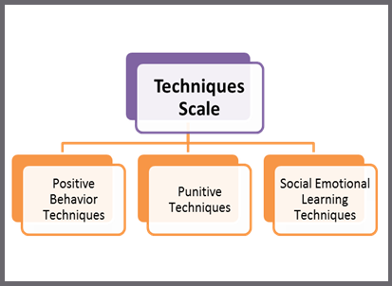

Response Scale: 1=Disagree A Lot 2=Disagree 3=Agree 4=Agree A Lot

Average Item Score Comparison – Techniques Scale BAR GRAPH (pg. 10)

*Note: Current year data is represented in BLUE
Graph | Use to… | Ask yourself…
Average Item Score Comparison– Techniques scale (Cross Year-Review) | Note your school’s average item scores per subscale for this school year and 2 previous years (if data are available). Note that the Punitive Techniques subscale was not included in the 2020-21 survey. | By subscale and overall, have our average item scores per subscale increased, decreased, or maintained over the years?

Our Increased Areas | Our Decreased Areas | Our Maintained Areas
Additional Notes

Average Item Score Comparison – Techniques Scale TABLE (pg. 10)

Table | Use to… | Ask yourself…
Techniques  Average Item Scores for All Staff Positions Combined | Note the sizable strengths and considerable concerns for YOUR school. The scores are a measure of how staff members perceive the techniques used by their peers. An average score of 3 or above means that the respondents on average agree or agree a lot. | What areas are strengths for our school? What areas do we need to address? Are there differences within or between position groups? Do staff members acknowledge the positive techniques used by their peers? Do staff members feel that their peers are more negative than positive?

Techniques Average Item Score Totals
Our Strengths | Concerns to Address
Additional Notes

Techniques by Position
Our Strengths | Concerns to Address
Additional Notes
Techniques Individual Item Responses (pg. 11)

Table | Use to… | Ask yourself…
Techniques Individual Item Responses  (Percentage Response Scores) | Note individual items that caused subscale scores to be low or high. By looking at this data, you can find out which items staff members feel strongly about and direct efforts accordingly. | Were there any individual items from a subscale that had particularly high or low response percentage? How did this impact our overall score? What can we do to address these focus areas?

Subscales | Our Strengths | Concerns to Address
Positive Behavioral Techniques
Punitive Techniques*
Social Emotional Learning Techniques
Additional Notes

*A high score on this subscale is negative because items are negatively worded

Techniques Standard Score TABLE (pg. 12)

Table | Use to… | Ask yourself…
Techniques Standard Scores  Compared with Other Participating Schools | Compare your school to other schools serving the same grade level (e.g. ES, MS, HS). A score of 100 is average, so in general, scores above 100 illustrate your school has higher scores than other same level schools. Remember, higher scores are preferred for positive techniques and SEL, and lower scores are better for punitive techniques. | What are our strengths and weaknesses compared to other schools that serve similar age students? Are there differences between and within position groups that we need to explore?

Techniques Scale Totals
Our Strengths | Concerns to Address
Additional Notes

Techniques by Position
Our Strengths | Concerns to Address
Additional Notes

INTERPRETING SIGNIFICANT DIFFERENCES IN SCORES
Schools may want to know if differences in scores (in subscales or from year to year) are “significant.” When thinking about significant differences, it is important to consider both practical significance and statistical significance.
- Practical significance: is the difference meaningful for our school?
- Statistical significance: 95% chance that the difference in scores is not due to chance
- *Statistical significance does not imply practical importance
  - A difference can be statistically significant but of little practical value
Schools should have little concern about significant differences when all of their scores are fairly high (e.g., above 3.3)
Schools should be less concerned about a difference from year to year than about general pattern in scores over multiple years
How to determine significant differences
The table below helps schools determine if the difference in two average item scores—which are the scores ranging from 1.0 to 4.0 and NOT STANDARD SCORES—are likely to be statistically significant.
Note that the table shows approximate size differences needed for statistical significance. They are approximate because exact scores would depend on the exact size of the samples and on the standard deviation for each score. Because both sample sizes and standard deviations vary greater when comparing scores across the hundreds of possible comparisons, only approximate values are given.
- Look at the number of respondents for the two given scores (i.e., the sample size, which we call N). If the number is different, use the lower N or an average of the two (e.g., 120 students completed the Teacher-Student subscale and 80 completed the Student-Student subscale, use 80 or 100, with 80 being more conservative).
- Find the number in Column 1 that is closest to your N.
- Find the number in Column 2 (Approximate Difference Needed) that aligns with your N. This difference is the minimal difference needed for statistical significance. For example, if you have 50 students, you need a difference of .20 or larger to conclude that there is a 95% chance that the difference is not an error and is statistically significant.

Approximate Difference in Average Item Scores (1.0-4.0) Needed to be
Statistically Significant
Size of Sample (N) | Approximate Difference Needed
15 | .38 or larger
20 | .33 or larger
30 | .29 or larger
40 | .26 or larger
50 | .20 or larger
60 | .19 or larger
70 | .17 or larger
80 | .16 or larger
90 | .15 or larger
100 | .14 or larger
120 | .13 or larger
140 | .12 or larger
160 | .11 or larger
200 | .10 or larger
240 | .09 or larger
310 | .08 or larger
400 | .07 or larger
540 | .06 or larger
780 | .05 or larger
Note. Statistical significance is at the .05 level (two-tailed t-test) and based on a standard deviation of .50 for each score. The statistical significance of differences would vary depending of the actual standard deviations.
Additional helpful notes to consider:
- Observe that as the size of the sample increases, the size of the difference needed for statistical significance decreases. Thus, be very cautious in concluding that differences are important when looking at small samples.
- Keep in mind that the actual score may be more meaningful than a statistically significant difference. For example, 2.7 may be significantly greater than 2.3, but both scores are low compared to other schools. Likewise, 3.8 may be significantly greater than 3.5 but both are very high and likely indicate no need for improvement.
- Be aware that the size of the differences needed for statistical significance are estimates.
- Be aware that practical significance is NOT the same as statistical significance. A good example is finding a difference of only .05 to be statistically significant in a sample of 800 students. Is that difference truly meaningful or of practical significance?

