**Delaware School Climate Survey Interpretation Worksheet**

**School Climate and Techniques**

**STAFF Version**

**General Review Guidance:**

* When reviewing data, note the number of respondents and reflect on the percentage of eligible participants (p. 2 of Interpretation Guidelines). There may be fewer responses than expected due to data cleaning process.
* Overall, missing scores indicate there were fewer than 5 surveys available to score this item; therefore, the scores are not reported.
* Note: The "Staff" position reporting includes administrators/supervisors, instructional or pupil support professional staff (e.g., School counselor, school psychologist, school nurse, librarian, educational diagnostician, consulting special education teacher), and paraprofessionals.

|  |  |  |  |  |
| --- | --- | --- | --- | --- |
| **Report Interpretation Key** | | | | |
| **Scales** |  | **Score Types** |  | **Color Codes** |
| School Climate | Average Item | **Bold** – Total Scores |
| Techniques | Percentage Response | Green – Favorable |
|  |  | Red – Unfavorable |

|  |  |  |
| --- | --- | --- |
| **Color Code Criteria for Average Item Scores** | | |
|  | **Favorable (GREEN)** | **Unfavorable (RED)** |
| **Scale** | **Average Item Score** | **Average Item Score** |
| School Climate & Techniques | 3.2 and above | 2.5 and below |
| School Climate – Bullying SW* | 2.0 and below | 3.0 and above |
| Techniques – Punitive* | 2.0 and below | 3.0 and above |

**Determine:** **How does one know if differences in scores are significant?**

See pg. 2 of Interpretation Guidelines within the report.

|  |
| --- |
| **Average Item Score Calculation** |
| Determine: Do your respondents’ scores reflect positive or negative perceptions of school climate regardless of how your school compares to other schools?  *Average scores are calculated by finding the average of all responses for each item.*  **Example:**  Responses to Item 5 = 2, 3, 3, 3, 4, 2  2 + 3 + 3 + 3 + 4 + 2 = 17  17 / 6 = 2.83  Average Item Score = 2.83 |

**TEACHER/STAFF DATA REPORT**

SS = 110

SS = 89

**School Climate Scale**

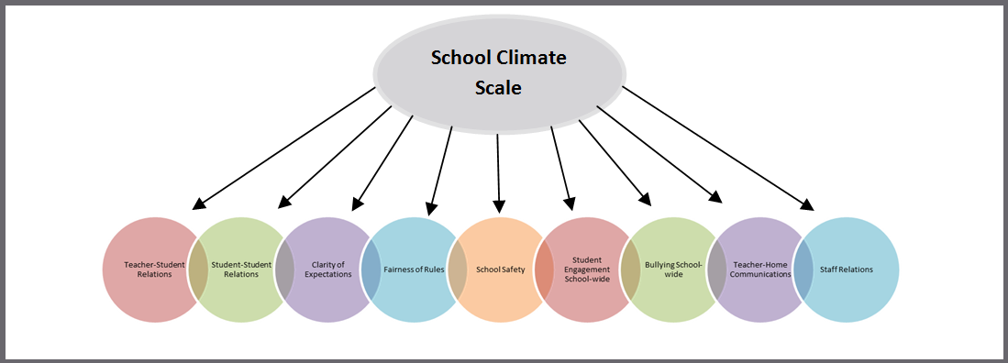

**Response Scale:** 1 = Disagree A Lot 2 = Disagree 3 = Agree 4 = Agree A Lot

**Average Item Score – School Climate Scale TABLE** (pg. 1)

|  |  |  |
| --- | --- | --- |
| **Table** | **Use to…** | **Ask yourself…** |
| Table I a. Average Item Scores for All Staff Positions Combined – *School Climate Scale* | Note the sizable strengths and considerable concerns for YOUR school. A score of *3 or above* means that the respondents on average agree or agree a lot. Remember, lower scores are preferred for Bullying School-wide. | What areas are strengths for our school? What areas do we need to address? Are there differences within or between position groups? Do staff members view student relationships positively? Do staff members feel rules are clear and fair? |

|  |  |
| --- | --- |
| **School Climate Average Item Score Totals** | |
| **Our Strengths** | **Concerns to Address** |
|  |  |
| **Additional Notes** | |
|  | |

|  |  |
| --- | --- |
| **School Climate Scale by *Position*** | |
| **Our Strengths** | **Concerns to Address** |
|  |  |
| **Additional Notes** | |
|  | |

**Average Item Score Comparison – School Climate Scale BAR GRAPH.** (pg. 2)

|  |  |  |
| --- | --- | --- |
| **Graph** | **Use to…** | **Ask yourself…** |
| Table I b. 3-Year Comparison – *School Climate Scale* | Note school’s average item scores per subscale for this school year and 2 previous years (if data are available). | By subscale and overall, have our average item scores per subscale increased, decreased, or maintained over the years? |

**\*Note: Current year data is represented in PURPLE**

|  |  |  |
| --- | --- | --- |
| **Our Increased Areas** | **Our Decreased Areas** | **Our Maintained Areas** |
|  |  |  |
| **Additional Notes** | | |

**School Climate Individual Item Responses** (pg. 3-4)

|  |  |  |
| --- | --- | --- |
| **Table** | **Use to…** | **Ask yourself…** |
| Table I c. Individual Item Responses – *School Climate Scale* | Note individual items that caused scores to be low or high. By looking at this data, you can find out which items staff members feel strongly about and direct efforts accordingly. | Were there any individual items from a subscale that had particularly high or low response percentage? How did this impact our overall score? What can we do to address these focus areas? |

|  |  |  |
| --- | --- | --- |
| **Subscales** | **Our Strengths** | **Concerns to Address** |
| Teacher-Student Relations |  |  |
| Student-Student Relations |  |  |
| Student Engagement School-wide |  |  |
| Clarity of Expectations |  |  |
| Fairness of Rules |  |  |
| School Safety |  |  |
| Teacher-Home Communications |  |  |
| Bullying School-wide* |  |  |
| Staff Relations |  |  |
| **Additional Notes** |  |  |

*\*A high score on this subscale is negative because items are negatively worded*

**TEACHER/STAFF DATA REPORT**

**Techniques Scale**

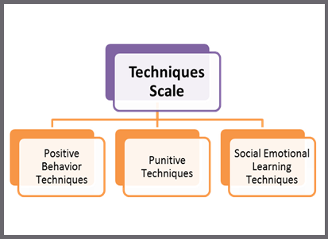

**Response Scale:** 1 = Disagree A Lot 2 = Disagree 3 = Agree 4 = Agree A Lot

**Average Item Score Comparison – Techniques Scale TABLE** (pg. 5)

|  |  |  |
| --- | --- | --- |
| **Table** | **Use to…** | **Ask yourself…** |
| Table II a. Average Item Scores for All Staff Positions Combined – *Techniques Scale* | Note the sizable strengths and considerable concerns for YOUR school. The scores are a measure of how staff members perceive the techniques used by their peers. An average score of *3 or above* means that the respondents on average agree or agree a lot. | What areas are strengths for our school? What areas do we need to address? Are there differences within or between position groups? Do staff members acknowledge the positive techniques used by their peers? Do staff members feel that their peers are more negative than positive? |

|  |  |
| --- | --- |
| **Techniques Average Item Score Totals** | |
| **Our Strengths** | **Concerns to Address** |
|  |  |
| **Additional Notes** | |
|  | |

|  |  |
| --- | --- |
| **Techniques by *Position*** | |
| **Our Strengths** | **Concerns to Address** |
|  |  |
| **Additional Notes** | |
|  | |

**Average Item Score Comparison – Techniques Scale BAR GRAPH** (pg. 5)

**\*Note: Current year data is represented in PURPLE**

|  |  |  |
| --- | --- | --- |
| **Graph** | **Use to…** | **Ask yourself…** |
| Table II b. 3-Year Comparison: Techniques Scale | Note your school’s average item scores per subscale for this school year and 2 previous years (if data are available). | By subscale and overall, have our average item scores per subscale increased, decreased, or maintained over the years? |

|  |  |  |
| --- | --- | --- |
| **Our Increased Areas** | **Our Decreased Areas** | **Our Maintained Areas** |
|  |  |  |
| **Additional Notes** | | |

**Techniques Individual Item Responses** (pg. 6)

|  |  |  |
| --- | --- | --- |
| **Table** | **Use to…** | **Ask yourself…** |
| Table II c. Individual Item Responses – *Techniques Scale* | Note individual items that caused subscale scores to be low or high. By looking at this data, you can find out which items staff members feel strongly about and direct efforts accordingly. | Were there any individual items from a subscale that had particularly high or low response percentage? How did this impact our overall score? What can we do to address these focus areas? |

|  |  |  |
| --- | --- | --- |
| **Subscales** | **Our Strengths** | **Concerns to Address** |
| Positive Behavioral Techniques |  |  |
| Punitive Techniques* |  |  |
| Social Emotional Learning Techniques |  |  |
| **Additional Notes** | | |

*\*A high score on this subscale is negative because items are negatively worded*