**Delaware School Climate Survey Interpretation Worksheet**

**School Climate, Techniques, Bullying, Engagement, Social Emotional Competencies**

**STUDENT Version**

**General Review Guidance:**

* When reviewing data, note the number of respondents and reflect on the percentage of eligible participants (p. 2 of Interpretation Guidelines). There may be fewer responses than expected due to data cleaning process.
* Note: If you notice grades listed outside of the population served, this is due to students selecting an inaccurate grade when taking the survey. While their grade info is null, their question responses are included in total scores.
* Overall, missing scores indicate there were fewer than 5 surveys available to score this item; therefore, the scores are not reported.

|  |  |  |  |  |
| --- | --- | --- | --- | --- |
| **Report Interpretation Key** | | | | |
| **Scales** |  | **Score Types** |  | **Color Codes** |
| School Climate | Average Item | **Bold** – Total Scores |
| Techniques | Percentage Response | Green – Favorable |
| Bullying |  | Red – Unfavorable |
| Engagement |  |  |
| Social Emotional Competencies |  |  |

|  |  |  |
| --- | --- | --- |
|  | **Favorable (GREEN)** | **Unfavorable (RED)** |
| **Scale** | **Average Item Score** | **Average Item Score** |
| School Climate, Techniques, Engagement, & SEC Scales | 3.2 and above | 2.5 and below |
| School Climate – Bullying SW* | 2.0 and below | 3.0 and above |
| Techniques – Punitive Techniques* | 2.0 and below | 3.0 and above |
| Bullying Scale | N/A | 3.0 and above |

|  |
| --- |
| **Average Item Score Calculation** |
| Determine: Do your respondents’ scores reflect positive or negative perceptions of school climate regardless of how your school compares to other schools?  *Average scores are calculated by finding the average of all responses for each item.*  **Example:**  Responses to Item 5 = 2, 3, 3, 3, 4, 2  2 + 3 + 3 + 3 + 4 + 2 = 17  17 / 6 = 2.83  Average Item Score = 2.83 |

**STUDENT DATA REPORT**

SS = 110

SS = 89

**School Climate Scale**

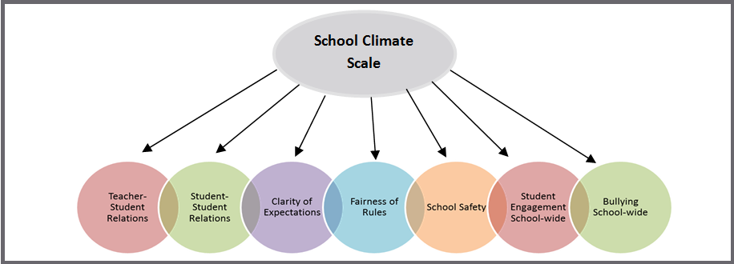

**Response Scale:** 1 = Disagree A Lot 2 = Disagree 3 = Agree 4 = Agree A Lot

**Average Item Score Comparison – School Climate Scale TABLE** (pg. 1-2)

|  |  |  |
| --- | --- | --- |
| **Table** | **Use to…** | **Ask yourself…** |
| Table I a. Average Item Scores for All Grades Combined – *School Climate Scale* | Note the sizable strengths and considerable concerns for YOUR school. A score of *3 or above* means that the respondents on average agree or agree a lot. Remember, lower scores are preferred for Bullying School-wide. | What areas are strengths for our school? What areas do we need to address? Are there differences within or between grade, race or gender groups? Do students view peer relationships positively? Do students feel rules are clear and fair? |

|  |  |
| --- | --- |
| **School Climate Average Item Score Totals** | |
| **Our Strengths** | **Concerns to Address** |
|  |  |
| **Additional Notes** | |
|  | |

|  |  |
| --- | --- |
| **School Climate Average Item Score *by Grade/Gender/Ethnicity*** | |
| **Our Strengths** | **Concerns to Address** |
|  |  |
| **Additional Notes** | |
|  | |

**Average Item Score Comparison – School Climate Scale BAR GRAPH** (pg. 3)

|  |  |  |
| --- | --- | --- |
| **Graph** | **Use to…** | **Ask yourself…** |
| Table I b. 3-Year Comparison: School Climate Scale | Note school’s average item scores per subscale for this school year and 2 previous years (if data are available). | By subscale and overall, have our average item scores per subscale increased, decreased, or maintained over the years? |

**\*Note: Current year data is represented in PURPLE**

|  |  |  |
| --- | --- | --- |
| **Our Increased Areas** | **Our Decreased Areas** | **Our Maintained Areas** |
|  |  |  |
| **Additional Notes** | | |

**School Climate Individual Item Responses** (pg. 4-5)

|  |  |  |
| --- | --- | --- |
| **Table** | **Use to…** | **Ask yourself…** |
| Table I c. Individual Item Reponses – *School Climate Scale* | Note individual items that caused scores to be low or high. By looking at this data, you can find out which items students feel strongly about and direct efforts accordingly. | Were there any individual items from a subscale that had a particularly high or low response percentage? How did this impact our overall score? What can we do to address these focus areas? |

|  |  |  |
| --- | --- | --- |
| **Subscales** | **Our Strengths** | **Concerns to Address** |
| Teacher-Student Relations |  |  |
| Student-Student Relations |  |  |
| Student Engagement School-wide |  |  |
| Clarity of Expectations |  |  |
| Fairness of Rules |  |  |
| School Safety |  |  |
| Bullying School-wide* |  |  |
| **Additional Notes** |  |  |

*A high score on this subscale is negative because items are negatively worded.

**STUDENT DATA REPORT**

**Techniques Scale**

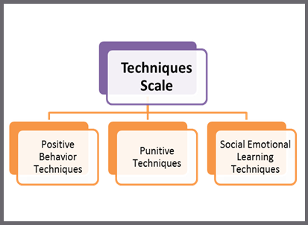

**Response Scale:** 1 = Disagree A Lot 2 = Disagree 3 = Agree 4 = Agree A Lot

**Average Item Score Comparison – Techniques Scale TABLE** (pg. 6-7)

|  |  |  |
| --- | --- | --- |
| **Table** | **Use to…** | **Ask yourself…** |
| Table II a. Average Item Scores for All Grades – *Techniques Scale* | Note the sizable strengths and considerable concerns for your school. The scores are a measure of how the students perceive the techniques used by the staff. An average score of *3 or above* means that the respondents on average agree or agree a lot. Remember, lower scores are preferred for Punitive Techniques. | What areas are strengths for our school? What areas do we need to address? Are there differences within or between grade, gender, or ethnicity groups? Do the students acknowledge the positive techniques used by staff? Do the students feel that staff is more negative (punitive) than positive? |

|  |  |
| --- | --- |
| **Techniques Average Item Score Totals** | |
| **Our Strengths** | **Concerns to Address** |
|  |  |
| **Additional Notes** | |
|  | |

|  |  |
| --- | --- |
| **Techniques Scale *by Grade/Gender/Ethnicity*** | |
| **Our Strengths** | **Concerns to Address** |
|  |  |
| **Additional Notes** | |
|  | |

**Average Item Score Comparison – Techniques Scale BAR GRAPH** (pg. 8)

**\*Note: Current year data is represented in PURPLE**

|  |  |  |
| --- | --- | --- |
| **Graph** | **Use to…** | **Ask yourself…** |
| Table II b. 3-Year Comparison: Techniques Scale | Note your school’s average item scores per subscale for this school year and 2 previous years (if data are available). | By subscale and overall, have our average item scores per subscale increased, decreased, or maintained over the years? |

|  |  |  |
| --- | --- | --- |
| **Our Increased Areas** | **Our Decreased Areas** | **Our Maintained Areas** |
|  |  |  |
| **Additional Notes** | | |

**Techniques Individual Item Responses** (pg. 9)

|  |  |  |
| --- | --- | --- |
| **Table** | **Use to…** | **Ask yourself…** |
| Table II c. Individual Item Reponses – Techniques Scale | Note individual items that caused subscale scores to be low or high. By looking at this data, you can find out which items students feel strongly about and direct efforts accordingly. | Were there any individual items from a subscale that had particularly high or low response percentage? How did this impact our overall score? What can we do to address these focus areas? |

|  |  |  |
| --- | --- | --- |
| **Subscales** | **Our Strengths** | **Concerns to Address** |
| Positive Techniques |  |  |
| Punitive Techniques* |  |  |
| SEL Techniques |  |  |
| **Additional Notes** | | |

*A high score on this subscale is negative because items are negatively worded.

**STUDENT DATA REPORT**

**Bullying Scale\***

*\*A high score on this scale is negative because items are negatively worded*

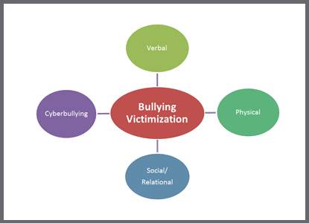

**Response Scale:** 1 = Never 2 = Less than once a month 3 = Once or twice a month

4 = Once a week 5 = Several times a week 6 = Every day

* Note: 3rd grade students do not receive Bullying Scale items. Cyberbullying items are intended for students in grades 6-12. If a school serving students PK-5 has cyberbullying data, this is due to students selecting a grade in the 6-12 range when taking the survey and leading them to receive these questions.

**Average Item Score Comparison – Bullying Scale TABLE** (pg. 10-11)

|  |  |  |
| --- | --- | --- |
| **Table** | **Use to…** | **Ask yourself…** |
| Table III a. Average Item Scores for All Grades – *Bullying Scale* | Note the sizable strengths and considerable concerns for your school. Explore students’ perceptions of the frequency of what types of bullying occur in the school. Keep in mind, lower scores are better. | What areas are strengths for our school? What areas do we need to address? Are there grade, race, or gender differences to explore? Are there differences in what types of bullying students perceive as a problem in your school? Do students see physical bullying as occurring more often than verbal? |

|  |  |
| --- | --- |
| **Bullying Average Item Score Totals** | |
| **Our Strengths** | **Concerns to Address** |
|  |  |
| **Additional Notes** | |
|  | |

|  |  |
| --- | --- |
| **Bullying *by Grade/Gender/Ethnicity*** | |
| **Our Strengths** | **Concerns to Address** |
|  |  |
| **Additional Notes** | |
|  | |

**Average Item Score Comparison – Bullying Scale BAR GRAPH** (pg. 12)

**\*Note: Current year data is represented in PURPLE**

|  |  |  |
| --- | --- | --- |
| **Graph** | **Use to…** | **Ask yourself…** |
| Table III b. 3-Year Comparison: Bullying Scale | Note school’s average item scores per subscale for this school year and 2 previous years (if data are available). | By subscale and overall, have our average item scores per subscale increased, decreased, or maintained over the years? |

|  |  |  |
| --- | --- | --- |
| **Our Increased Areas** | **Our Decreased Areas** | **Our Maintained Areas** |
|  |  |  |
| **Additional Notes** | | |

**Bullying Individual Item Responses** (pg. 13-14)

|  |  |  |
| --- | --- | --- |
| **Table** | **Use to…** | **Ask yourself…** |
| Table III c. Individual Item Responses – Bullying Scale | Review students’ responses to the individual questions. Note individual items that caused subscale scores to be low or high. By looking at this data, you can identify items students note as occurring more or less frequently. | Were there any individual items from a subscale that had particularly high or low response percentage? How did this impact our overall score? What can we do to address these focus areas? |

|  |  |  |
| --- | --- | --- |
| **Subscales** | **Our Strengths** | **Concerns to Address** |
| Verbal Bullying |  |  |
| Physical Bullying |  |  |
| Social/Relational Bullying |  |  |
| Cyberbullying  *(6th-12th grade only)* |  |  |
| **Additional Notes** | | |

**STUDENT DATA REPORT**

**Engagement Scale**

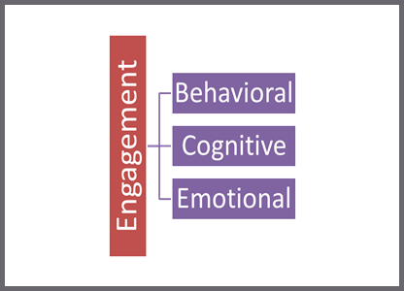

**Response Scale:** 1 = Disagree A Lot 2 = Disagree 3 = Agree 4 = Agree A Lot

**Average Item Score Comparison – Engagement Scale TABLE** (pg. 15-16)

|  |  |  |
| --- | --- | --- |
| **Table** | **Use to…** | **Ask yourself…** |
| Table IV a. Average Item Scores for All Grades – *Engagement Scale* | Note the sizable strengths and considerable concerns for your school. A score of 3 or above means that the respondents on average agree or agree a lot. | What areas are strengths for our school? What areas do we need to address? Are there differences within or between grade, race or gender groups? Do our students report being more cognitively, behaviorally, or emotionally engaged? |

|  |  |
| --- | --- |
| **Engagement Average Item Score Totals** | |
| **Our Strengths** | **Concerns to Address** |
|  |  |
| **Additional Notes** | |
|  | |

|  |  |
| --- | --- |
| **Engagement b*y Grade/Gender/Ethnicity*** | |
| **Our Strengths** | **Concerns to Address** |
|  |  |
| **Additional Notes** | |
|  | |

**Average Item Score Comparison – Engagement Scale BAR GRAPH** (pg. 17)

**\*Note: Current year data is represented in PURPLE**

|  |  |  |
| --- | --- | --- |
| **Graph** | **Use to…** | **Ask yourself…** |
| Table IV b. 3-Year Comparison: Engagement Scale | Note school’s average item scores per subscale for this school year and 2 previous years (if data are available). | By subscale and overall, have our average item scores per subscale increased, decreased, or maintained over the years? |

|  |  |  |
| --- | --- | --- |
| **Our Increased Areas** | **Our Decreased Areas** | **Our Maintained Areas** |
|  |  |  |
| **Additional Notes** | | |

**Engagement Individual Item Responses** (pg. 18)

|  |  |  |
| --- | --- | --- |
| **Table** | **Use to…** | **Ask yourself…** |
| Table IV c. Individual Item Responses – Engagement Scale | Note individual items that caused subscale scores to be low or high. By looking at this data, you can find out which items students feel strongly about and direct efforts accordingly. | Were there any individual items from a subscale that had particularly high or low response percentage? How did this impact our overall score? What can we do to address these focus areas? |

|  |  |  |
| --- | --- | --- |
| **Subscales** | **Our Strengths** | **Concerns to Address** |
| Cognitive Engagement |  |  |
| Behavioral Engagement |  |  |
| Emotional Engagement |  |  |
| **Additional Notes** | | |

**STUDENT DATA REPORT**

**Social and Emotional Competencies Scale**

**Response Scale:** 1 = Disagree A Lot 2 = Disagree 3 = Agree 4 = Agree A Lot

**Average Item Score Comparison – Social Emotional Competencies TABLE** (pg. 19-20)

|  |  |  |
| --- | --- | --- |
| **Table** | **Use to…** | **Ask yourself…** |
| Table V a. Average Item Scores for All Grades – *Social Emotional Competencies Scale* | Note the sizable strengths and considerable concerns for your school. A score of *3 or above* means that the students on average feel the statement is somewhat or very much like them. | Is this an area of strength or concern for our school? Are there differences between grade, gender, or ethnicity groups? |

|  |  |
| --- | --- |
| **Social Emotional Competencies Average Item Score Totals** | |
| **Our Strengths** | **Concerns to Address** |
|  |  |
| **Additional Notes** | |
|  | |
| **Social Emotional Competencies *by Grade/Gender/Ethnicity*** | |
| **Our Strengths** | **Concerns to Address** |
|  |  |
| **Additional Notes** | |
|  | |

**Average Item Score Comparison – Social Emotional Competencies**

**BAR GRAPH** (pg. 21)

**\*Note: Current year data is represented in PURPLE**

|  |  |  |
| --- | --- | --- |
| **Graph** | **Use to…** | **Ask yourself…** |
| Table V b. 3-Year Comparison: Social Emotional Competencies Scale | Note school’s average item total score for this school year and last year (if data is available). | Has our total average item score increased, decreased, or maintained since last year? |

|  |  |  |
| --- | --- | --- |
| **Our Increased Areas** | **Our Decreased Areas** | **Our Maintained Areas** |
|  |  |  |
| **Additional Notes** | | |

**Social Emotional Competencies Individual Item Responses** (pg. 21-23)

|  |  |  |
| --- | --- | --- |
| **Table** | **Use to…** | **Ask yourself…** |
| Table V c. Individual Item Responses – Social-Emotional Competencies | Note individual items that caused the total score to be low or high. By looking at this data, you can find out which items students self-identify with and direct efforts accordingly. | Were there any individual items that had a particularly high or low response percentage? How did this impact our overall score? What can we do to address these focus areas? |

|  |  |  |
| --- | --- | --- |
| **Social Emotional Competencies**  **Subscales** | **Our Strengths** | **Concerns to Address** |
| Responsible Decision Making |  |  |
| Social Awareness |  |  |
| Self-management of  Emotions & Behavior |  |  |
| Self-Awareness |  |  |
| Relationship Skills |  |  |
| **Additional Notes** | | |